SPrint FOur

**CS2450-002, Team 2**

Cody Strange-*Scribe and Information Manager*

Ethan Taylor-*GUI Developer*

Jaden Albrecht-*Team Manager*

Tyler Deschamps-*Chart and Milestone document builder*

Jordan Van Patten-*V&V and Tester*

Craig Sharp-*Stakeholder*

Table of contents

*Management……………………………………………………….........................................*3

*Procedures……………………………………...…………………………………………………………..*3

*Plans…….……………………………………...………………………………………………………….*24

*Previous Sprint Items…...…………………...………………………………………………………….*24

Deployment………………………………………..……………………………………...…...27

*Scope…………….*………………………….…………………………………………………………27

*Cutover………….*………………………….…………………………………………………………28

*Deployment Plan*………………………….…………………………………………………………28

Testing…………………………………………………………………………………...…..…30

*Testing……………………..*……………………………………………………………………...…..30

*Bug Tracking*……………………..……………………………………………………………….…63

Charts/Templates…………………………………………………………………………..…64

*Work breakdown structure*……………………………………………………………………...…..65

*Pert Chart*………………………..…………………………………………………………………..66

*Gantt Chart*…………………..………………………………………………………………………67

*Burndown Chart*…………..………………………………………………………………………...68

Meeting Logs…………………………………………………………………………………..68

*Meeting Log#9*……………………………………………………………………………………….70

*Meeting Log#10*………………………..…………………………………………………………….72

Management

Procedures

*Verification & Validation*

Summary: V&V documents for sprint four specifically

|  |
| --- |
| **Application Quality Assurance Checklist** |
| **Purpose:**  The Application Quality Assurance Checklist is intended to ensure “Custom-Built” applications adhere to development practices that promote quality solutions. It is recommended that the project team familiarize themselves with this checklist during the Design stage to ensure the developed application meets the quality standards when reviewed in the Execute stage.  This deliverable should be listed as a requirement in the Transition Agreement. |

|  |  |  |  |
| --- | --- | --- | --- |
| **Project Name** | EmpDat | **Project #** | SPR-4 |
| **Application Name** |  | **Application #** |  |
| **Project Manager** |  | **Delivery Manager** |  |
| **Date Completed** | 3/21/2022 | | |

|  |
| --- |
| **Important Notes for Completing this Document**  Each section of the Application Quality Assurance Checklist template must be completed in full.  If a particular section is not applicable to this project, then you must write **Not Applicable** and provide a reason.  **Important Note**: No sections are to be deleted from this document.  This template is not to be modified in any manner.  Text contained within << >> provides information on how to complete that section and can be deleted once the section has been completed. |

| 1. **Development Framework** | | | | |
| --- | --- | --- | --- | --- |
| ***Validation Questions*** | **Yes** | **No** | **NA** | **Comments** |
| 1. Has the application been developed with the most recent OCIO-sanctioned version of the framework for the chosen technology? | ☒ | ☐ | ☐ |  |

| 1. **Development IDE**   Applications should be developed using an OCIO-sanctioned Integrated Development Environment (IDE).  This will allow Application Services resources to build and debug source code as needed. | | | | |
| --- | --- | --- | --- | --- |
| ***Validation Questions*** | **Yes** | **No** | **NA** | **Comments** |
| 1. Has the application been developed using an Integrated Development Environment that was approved by the OCIO? | ☒ | ☐ | ☐ |  |

| 1. **Decoupling Business Logic From The Presentation Layer**   Whenever possible, developers should avoid using business logic in the presentation layer.  The presentation layer should mainly be used for navigation throughout the application and presenting data to the user.  For example, the use of Java code directly within JSP pages (i.e. Scriptlets) should be avoided.  The preferred approach would be to use Tag Libraries (JSTL/EL).  Also, the Presentation Layer of Web applications should be developed using prevailing industry standards (e.g. using Stylesheets to position and control presentation elements, using relative positioning instead of absolute positioning, etc.). | | | | |
| --- | --- | --- | --- | --- |
| ***Validation Questions*** | **Yes** | **No** | **NA** | **Comments** |
| 1. Is the presentation layer of the application free from business logic? | ☒ | ☐ | ☐ |  |
| 1. Has the presentation layer of the application been developed in accordance with prevailing industry standards? | ☒ | ☐ | ☐ |  |

| 1. **Record Locking / Concurrent Users**   Applications should be developed in such a way that users’ changes do not clash with each other or create the potential for data loss/corruption. | | | | |
| --- | --- | --- | --- | --- |
| ***Validation Questions*** | **Yes** | **No** | **NA** | **Comments** |
| 1. Have precautions been taken to avoid data clashes? | ☒ | ☐ | ☐ |  |

| 1. **Passwords**   A password helps authenticate a user when accessing a software application.  Adherence to appropriate password management will help maintain the confidentiality, integrity, availability of the data maintained by the software application and reduce the risk of inappropriate access and use. | | | | |
| --- | --- | --- | --- | --- |
| ***Validation Questions*** | **Yes** | **No** | **NA** | **Comments** |
| 1. Does the system have functionality to allow the user to revise their password and force user account expiry? | ☐ | ☒ | ☐ | The user is able to change their password, but does not force user account expiry, because user accounts would be deactivated or expired by an admin |
| 1. Does the system support protected storage of passwords with privileged user access?  The system ***should not*** support passwords in clear text embedded either in the application code, automated scripts, or the database? | ☐ | ☒ | ☐ |  |
| 1. Does the system meet the standard password requirements? | ☐ | ☒ | ☐ | Password requirements will be added in at a later execution of our program |
| 1. Are the passwords in the production environment different than those in a non-production environment? | ☒ | ☐ | ☐ | For now, passwords in the production environment do not currently have any requirements, but that will change later |
| 1. Are all vendor supplied default passwords revised prior to placing the application in a production environment? | ☐ | ☒ | ☐ |  |
| 1. Are passwords for privileged accounts different than passwords for non-privileged accounts? | ☒ | ☐ | ☐ | They are different passwords if the user chooses, but the user is the one that chooses passwords |

| 1. **Logging and Auditing** | | | | |
| --- | --- | --- | --- | --- |
| ***Validation Questions*** | **Yes** | **No** | **NA** | **Comments** |
| 1. Based on the application’s Information Security Classification, does the application meet the logging functional control requirements? | ☐ | ☐ | ☒ |  |
| 1. Based on the application’s Information Security Classification, does the application meet the auditing functional control requirements? | ☐ | ☐ | ☒ |  |

| 1. **Modularized Code With No Duplication**   As much as possible, code should be organized into small, separate modules to avoid code duplication and to make future code changes easier to implement. | | | | |
| --- | --- | --- | --- | --- |
| ***Validation Questions*** | **Yes** | **No** | **NA** | **Comments** |
| 1. Is the application modularized? | ☒ | ☐ | ☐ |  |
| 1. Has code duplication been avoided? | ☒ | ☐ | ☐ |  |

| 1. **Consistency of Code**   Code sections with similar functionality should be written in a clear, predicable, and consistent way.  Using different approaches to achieve the same basic purposes should be avoided.  Project teams consisting of multiple developers should ensure that the developers follow the same coding style and naming conventions. | | | | |
| --- | --- | --- | --- | --- |
| ***Validation Questions*** | **Yes** | **No** | **NA** | **Comments** |
| 1. Is the code written in a consistent manner throughout the application? | ☒ | ☐ | ☐ |  |
| 1. Have all developers followed the same coding style and naming conventions? | ☒ | ☐ | ☐ |  |
| 1. Have all developers followed the coding best practices as set out by the organization which owns the technology? | ☒ | ☐ | ☐ |  |

| 1. **Code Comments**   Code sections should be well documented with comments.  At a minimum, each section of code (code unit) should have an introductory brief and accurate description to explain the code functionality.  Any potentially confusing / non-intuitive sections of code should be commented thoroughly. | | | | |
| --- | --- | --- | --- | --- |
| ***Validation Questions*** | **Yes** | **No** | **NA** | **Comments** |
| 1. Does all application code include sufficient comments for support personnel? | ☒ | ☐ | ☐ |  |
| 1. Does each code unit have its own brief and accurate description? | ☒ | ☐ | ☐ |  |

|  |  |  |  |  |
| --- | --- | --- | --- | --- |
| 1. **Error Handling – End User**   Error messages presented to the end user should contain only that information which will allow the user to take corrective action (e.g. “Invalid date, please reenter in YYYY-MM-DD format”). In the case of unhandled exceptions, messages should be generic. Avoid displaying system information in error messages such as server names, versions, and patch information, as well as application variables, paths, and other configuration information. Avoid messages that could potentially lead to system exploitation (e.g. “Incorrect Login” is acceptable while the message “Incorrect Password” is not).  Error handling logic should be robust enough to gracefully and meaningfully handle all errors which could be reasonably expected to occur from user interactions with the system.  The text for error messages should be contained in a single location within the application code or database to facilitate quick additions and modifications by support staff. | | | | |
| ***Validation Questions*** | **Yes** | **No** | **NA** | **Comments** |
| 1. Does the application handle all the errors that could reasonably be expected to occur? | ☒ | ☐ | ☐ |  |
| 1. Do the error messages contain minimal but meaningful information? | ☒ | ☐ | ☐ |  |
| 1. Does the application avoid displaying system information in error messages? | ☒ | ☐ | ☐ |  |
| 1. Are the error messages kept in a single location? | ☐ | ☒ | ☐ | Error messages are kept in separate locations in the code, and in the application it is shown below the effected area, I.E. if date is incorrect, it will display the error message below the date entry box |

| 1. **Error Logging**   Application errors should be logged for support personnel in database tables that will be directly accessible to Application Services personnel.  SQL can then be used to aid in searches for specific errors.  Log files for individual server tiers (i.e. Web and Application tiers) should be kept in a single directory on each server.  Also, log files should be saved on a daily basis with a time-date stamp on each file.  The error messages that are logged should contain information that is useful for support personnel (absolutely no sensitive or personal data), such as which module of code encountered the error and what the specific error was.  Meaningful and detailed error messages are particularly important when troubleshooting unknown/unexpected errors.  These should definitely be captured and logged.  Logging is also required for applications as well as batch/scheduled jobs.  Logging logic within applications should be written in a modular way to facilitate the easy addition of new error messages. | | | | |
| --- | --- | --- | --- | --- |
| ***Validation Questions*** | **Yes** | **No** | **NA** | **Comments** |
| 1. Are all errors for the application being logged? | ☒ | ☐ | ☐ | We are manually logging any errors we find |
| 1. Is logging being done on each server tier? | ☐ | ☒ | ☐ |  |
| 1. Are the logs kept in a single location / directory / database? | ☒ | ☐ | ☐ | We use an internet applicatin where we report our bugs/errors |
| 1. Are the logged errors specific enough to assist support personnel in troubleshooting production problems? | ☒ | ☐ | ☐ |  |
| 1. Is the code that logs the error messages written in a modular way? | ☒ | ☐ | ☐ |  |
| 1. Are the log files free of personally sensitive or identifiable information? | ☒ | ☐ | ☐ |  |

| 1. **Field Validations**   Where possible, validations should be performed on both the presentation layer and the business layer.  In Java, for example, validations may be done using JavaScript within JSP pages (presentation layer), but should also be done within Java classes on the business layer.   Also, validations should be performed in such a way that they cannot be bypassed by end-users (e.g. by disabling JavaScript).  Field lengths and types within an application should be consistent with the column lengths and types declared within the underlying database tables. | | | | |
| --- | --- | --- | --- | --- |
| ***Validation Questions*** | **Yes** | **No** | **NA** | **Comments** |
| 1. Are fields being checked for the correct type (e.g. date, integer, etc.) and the correct range of values (e.g. 1 – 12 for month)? | ☒ | ☐ | ☐ |  |
| 1. Are field values being validated with regular expressions where possible (e.g. validating email addresses and dates for valid formats)? | ☒ | ☐ | ☐ | Date of birth is not currently being validated |
| 1. Do the validations resulting in error messages prevent data from being written to persistent storage (databases, files, etc.)? | ☒ | ☐ | ☐ |  |
| 1. Are the validations being performed within the business logic, as well as on the presentation layer? | ☒ | ☐ | ☐ |  |
| 1. Have the validations been written so that users cannot bypass them? | ☒ | ☐ | ☐ |  |
| 1. Are all of the field lengths and types within the application consistent with the column lengths and types declared within the underlying database tables? | ☒ | ☐ | ☐ |  |
| 1. Are user inputs being sanitized (without exceptions) according to OWASP recommendations? | ☒ | ☐ | ☐ |  |

| 1. **Dates**   When testing functionality that is built around date checks, the testers should use date values that occur in the past, on the target date, and in the future.  Dates should also be validated in the context of the established business rules of the application (e.g. given a person’s birth date, is he/she eligible to vote?).  When dates are recorded in a database or log, they should include a timestamp and not just the month, day, and year.  Timestamps will not be required in specific situations (such as a birth date field) where a timestamp does not make sense. | | | | |
| --- | --- | --- | --- | --- |
| ***Validation Questions*** | **Yes** | **No** | **NA** | **Comments** |
| 1. Does the application validate dates in a way that is consistent with the system design specifications and business rules? | ☐ | ☒ | ☐ | Dates are automatically inputted by the code, not by the user, so there is no date validation. DOB is not yet validated and mandated to be in the month/day/year format but will be added in a future version |
| 1. Do all relevant dates include a timestamp? | ☐ | ☒ | ☐ |  |

| 1. **Hard-Coded Values**   Hard-coding of server names, database names, domain names, IP addresses, etc. within application code should be avoided.  These values should be contained in a single configuration file or database that is not part of the application build, so that it can be easily maintained for different server environments (development, testing/staging, and production) and will not need to be modified when new changes are built and deployed.  Fixed values that are repeatedly used throughout application code should be declared in a single location and referenced appropriately, as needed, within the application.  As a practical guide, a change to one of these values should occur within a single reference point. | | | | |
| --- | --- | --- | --- | --- |
| ***Validation Questions*** | **Yes** | **No** | **NA** | **Comments** |
| 1. Does the application code avoid use of hard-coded values? | ☒ | ☐ | ☐ |  |
| 1. Do all hard-coded values reside exclusively within configuration and constant, centralized locations? (Central Locations  that enable changes without recompiling source code) | ☒ | ☐ | ☐ |  |

| 1. **System Testing**   System testing should consist of negative testing, as well as positive testing.  During positive testing (“Testing to Pass”), the testers will ensure that a program behaves as it should (in terms of navigation, processing, reading and writing records, etc.).  During negative testing (“Testing to Fail”), the testers will ensure that a program does not behave in a way that it shouldn’t (e.g. allowing a past date to be entered into a future date field). | | | |
| --- | --- | --- | --- |
| ***Validation Questions*** | **Yes** | **No** | **Comments** |
| 1. Did the application pass all positive tests? | ☒ | ☐ | There was one positive test that failed, but the rest of them passed. The test that failed was editing a user’s ID, and then searching for that user afterwards |
| 1. Did the application pass all negative tests? | ☒ | ☐ |  |
| 1. Have client testers completed the formal test plan in its entirety? | ☐ | ☒ | We have not made a formal test plan yet |
| 1. Did the application pass all tests included in the formal test plan? | ☐ | ☒ |  |
| 1. Have all positive / negative test cases and test case results been documented? | ☒ | ☐ |  |

| 1. **Regression Testing**   Regression Testing is any type of software testing that seeks to uncover new errors or regressions in existing functionality after changes have been made to the software, such as functional enhancements, patches or configuration changes.  Regression testing ensures functionality that was working yesterday is still working today.  New functionality should be added to a system without impairing existing functionality or introducing bugs. | | | | |
| --- | --- | --- | --- | --- |
| ***Validation Questions*** | **Yes** | **No** | **NA** | **Comments** |
| 1. As new capability is introduced, is the new capability tested? | ☒ | ☐ | ☐ |  |
| 1. Have all previous tests been reconducted with the results compared against expected results? | ☒ | ☐ | ☐ |  |
| 1. Is every capability of the software supported with a test case and is the test case added to the test case library to support final and future system testing? | ☒ | ☐ | ☐ |  |
| 1. As bugs are detected and fixed, is the test that exposed the bug recorded and regularly re-tested after subsequent changes are applied to the application? | ☒ | ☐ | ☐ |  |

| 1. **Load Testing/Volume Testing**   The load/volume testing that is performed on an application should be reflective of the demands that could reasonably be expected to occur when the application goes into production.  The testing should try to anticipate future system growth, data growth, and an increase in the number of active users. | | | | |
| --- | --- | --- | --- | --- |
| ***Validation Questions*** | **Yes** | **No** | **NA** | **Comments** |
| 1. Has the application been tested with a large number of concurrent users (i.e. a number of users that is representative of peak system usage)? | ☐ | ☒ | ☐ |  |
| 1. Has the application been tested with large numbers of concurrent transactions (i.e. a number of transactions that is representative of peak system usage)? | ☐ | ☒ | ☐ |  |
| 1. Did the system perform well with a large number of concurrent users? | ☐ | ☐ | ☒ |  |
| 1. Did the system perform well with a large number of concurrent transactions? | ☐ | ☐ | ☒ |  |
| 1. Are end-users satisfied with the application’s performance and responsiveness during everyday use? | ☐ | ☐ | ☒ |  |

| 1. **Certificates / Environment Software**   Any certificates or special software that needs to be installed on a server stack for an application to function (e.g. virus scanning software, SSL Certificates, etc.) should be documented in the Operations Procedure Manual.  Documentation should include the relevant expiration dates and the processes that must be followed for renewal.  Also, application deployments in production environments should not be comprised of any trial versions of software.  All proprietary and copyrighted software should be properly licensed for Government use. | | | | |
| --- | --- | --- | --- | --- |
| ***Validation Questions*** | **Yes** | **No** | **NA** | **Comments** |
| 1. Has all proprietary and copyrighted software been properly licensed for government use? | ☐ | ☒ | ☐ |  |
| 1. Have special software/certificate requirements been documented? | ☐ | ☒ | ☐ |  |
| 1. Does the documentation provide expiration dates and instructions for renewal? | ☐ | ☒ | ☐ |  |
| 1. Is the system / application free from trial versions of software? | ☐ | ☐ | ☒ |  |

| 1. **Business Requirements - Traceability**   All of the business requirements that have been captured and agreed upon by the project stakeholders should be fully met in the final version of the application that is transitioned over to Application Services.  All required system functionality should also be fully satisfied by this final version. | | | | |
| --- | --- | --- | --- | --- |
| ***Validation Questions*** | **Yes** | **No** | **NA** | **Comments** |
| 1. Have all of the business requirements been met by the finished application? | ☐ | ☐ | ☒ | The application is not yet finished, but we have met the requirements given for this current phase |
| 1. Has all of the required functionality been met by the finished application? | ☒ | ☐ | ☐ | The current application’s requirements are met by what we currently have for our application |

| 1. **Source Code** | | | | |
| --- | --- | --- | --- | --- |
| ***Validation Questions*** | **Yes** | **No** | **NA** | **Comments** |
| 1. Has the final approved version of the Application Code been provided to Application Services for use and maintenance during the Transition Period? | ☐ | ☐ | ☒ | We do not have the final version of our code |
| 1. Has a test build been completed by Application Services using the code that has been handed over? | ☐ | ☐ | ☒ |  |
| 1. Has a copy of the version of Open Source Code used by the application been provided to Application Services for retention? (Links are not recommended) | ☒ | ☐ | ☐ |  |
| 1. Have the 3rd party developer code / plug-ins (e.g. Axis2, Eclipse) been identified and provided to Application Services for the continued maintenance of the application? (Links to the utility not satisfactory, 3rd party products need to be provided) | ☐ | ☐ | ☒ |  |

| 1. **Database Design**   Industry best practices should be followed in the design of databases for production applications: tables normalized, exceptions documented, constraints enforced, and required fields completed (nulls not permitted).  Also, if table keys are based on sequence numbers, each table should have its own sequence. | | | | |
| --- | --- | --- | --- | --- |
| ***Validation Questions*** | **Yes** | **No** | **NA** | **Comments** |
| 1. Have the database tables been normalized? | ☒ | ☐ | ☐ |  |
| 1. Keys based on sequence numbers have unique sequences. | ☒ | ☐ | ☐ |  |
| 1. Are all keys and required fields set to ‘not null’ in all tables of the database? | ☒ | ☐ | ☐ |  |
| 1. Have triggers, stored procedures, sequences, and constraints been properly utilized? | ☐ | ☐ | ☒ |  |

| 1. **Transition To Support Personnel**   The necessary server environments to support an application (development, test/staging, and production) should be fully constructed prior to transition and should be entirely consistent with each other with respect to Operating Systems, software versions, database versions, environment hardening, configuration, etc.  The Application Services resources supporting an application should be granted access to development, test/staging, and production environments (as appropriate) prior to transition. | | | | |
| --- | --- | --- | --- | --- |
| ***Validation Questions*** | **Yes** | **No** | **NA** | **Comments** |
| 1. Have accounts been created on all servers for the appropriate support personnel? | ☐ | ☒ | ☐ |  |
| 1. Have the necessary firewall rules been added to allow Application Services support personnel to access the relevant servers (i.e. via the Jump Box)? | ☐ | ☒ | ☐ |  |
| 1. Have all server environments (development, test/staging, and production) been fully created? | ☐ | ☒ | ☐ |  |
| 1. Are all of the server environments entirely consistent with each other? | ☐ | ☒ | ☐ |  |

| 1. **Checklist Exceptions**   If the answer was ‘no’ for any of the checklist items above, please explain why in this section. |
| --- |
| << Please explain any exceptions using specific reference numbers from above. >> |

|  |  |
| --- | --- |
| **prepared By** | |
| Project Manager |  |
| Print name                 Signature                       Date (YYYY-MM-DD) |
| **reviewed By** | |
| **Application Services  Team Lead** |  |
| Print name                 Signature                       Date (YYYY-MM-DD) |

#### SPR-4 Change Order Forms

Summary: These are all of the change order forms that have been filled out for this sprint

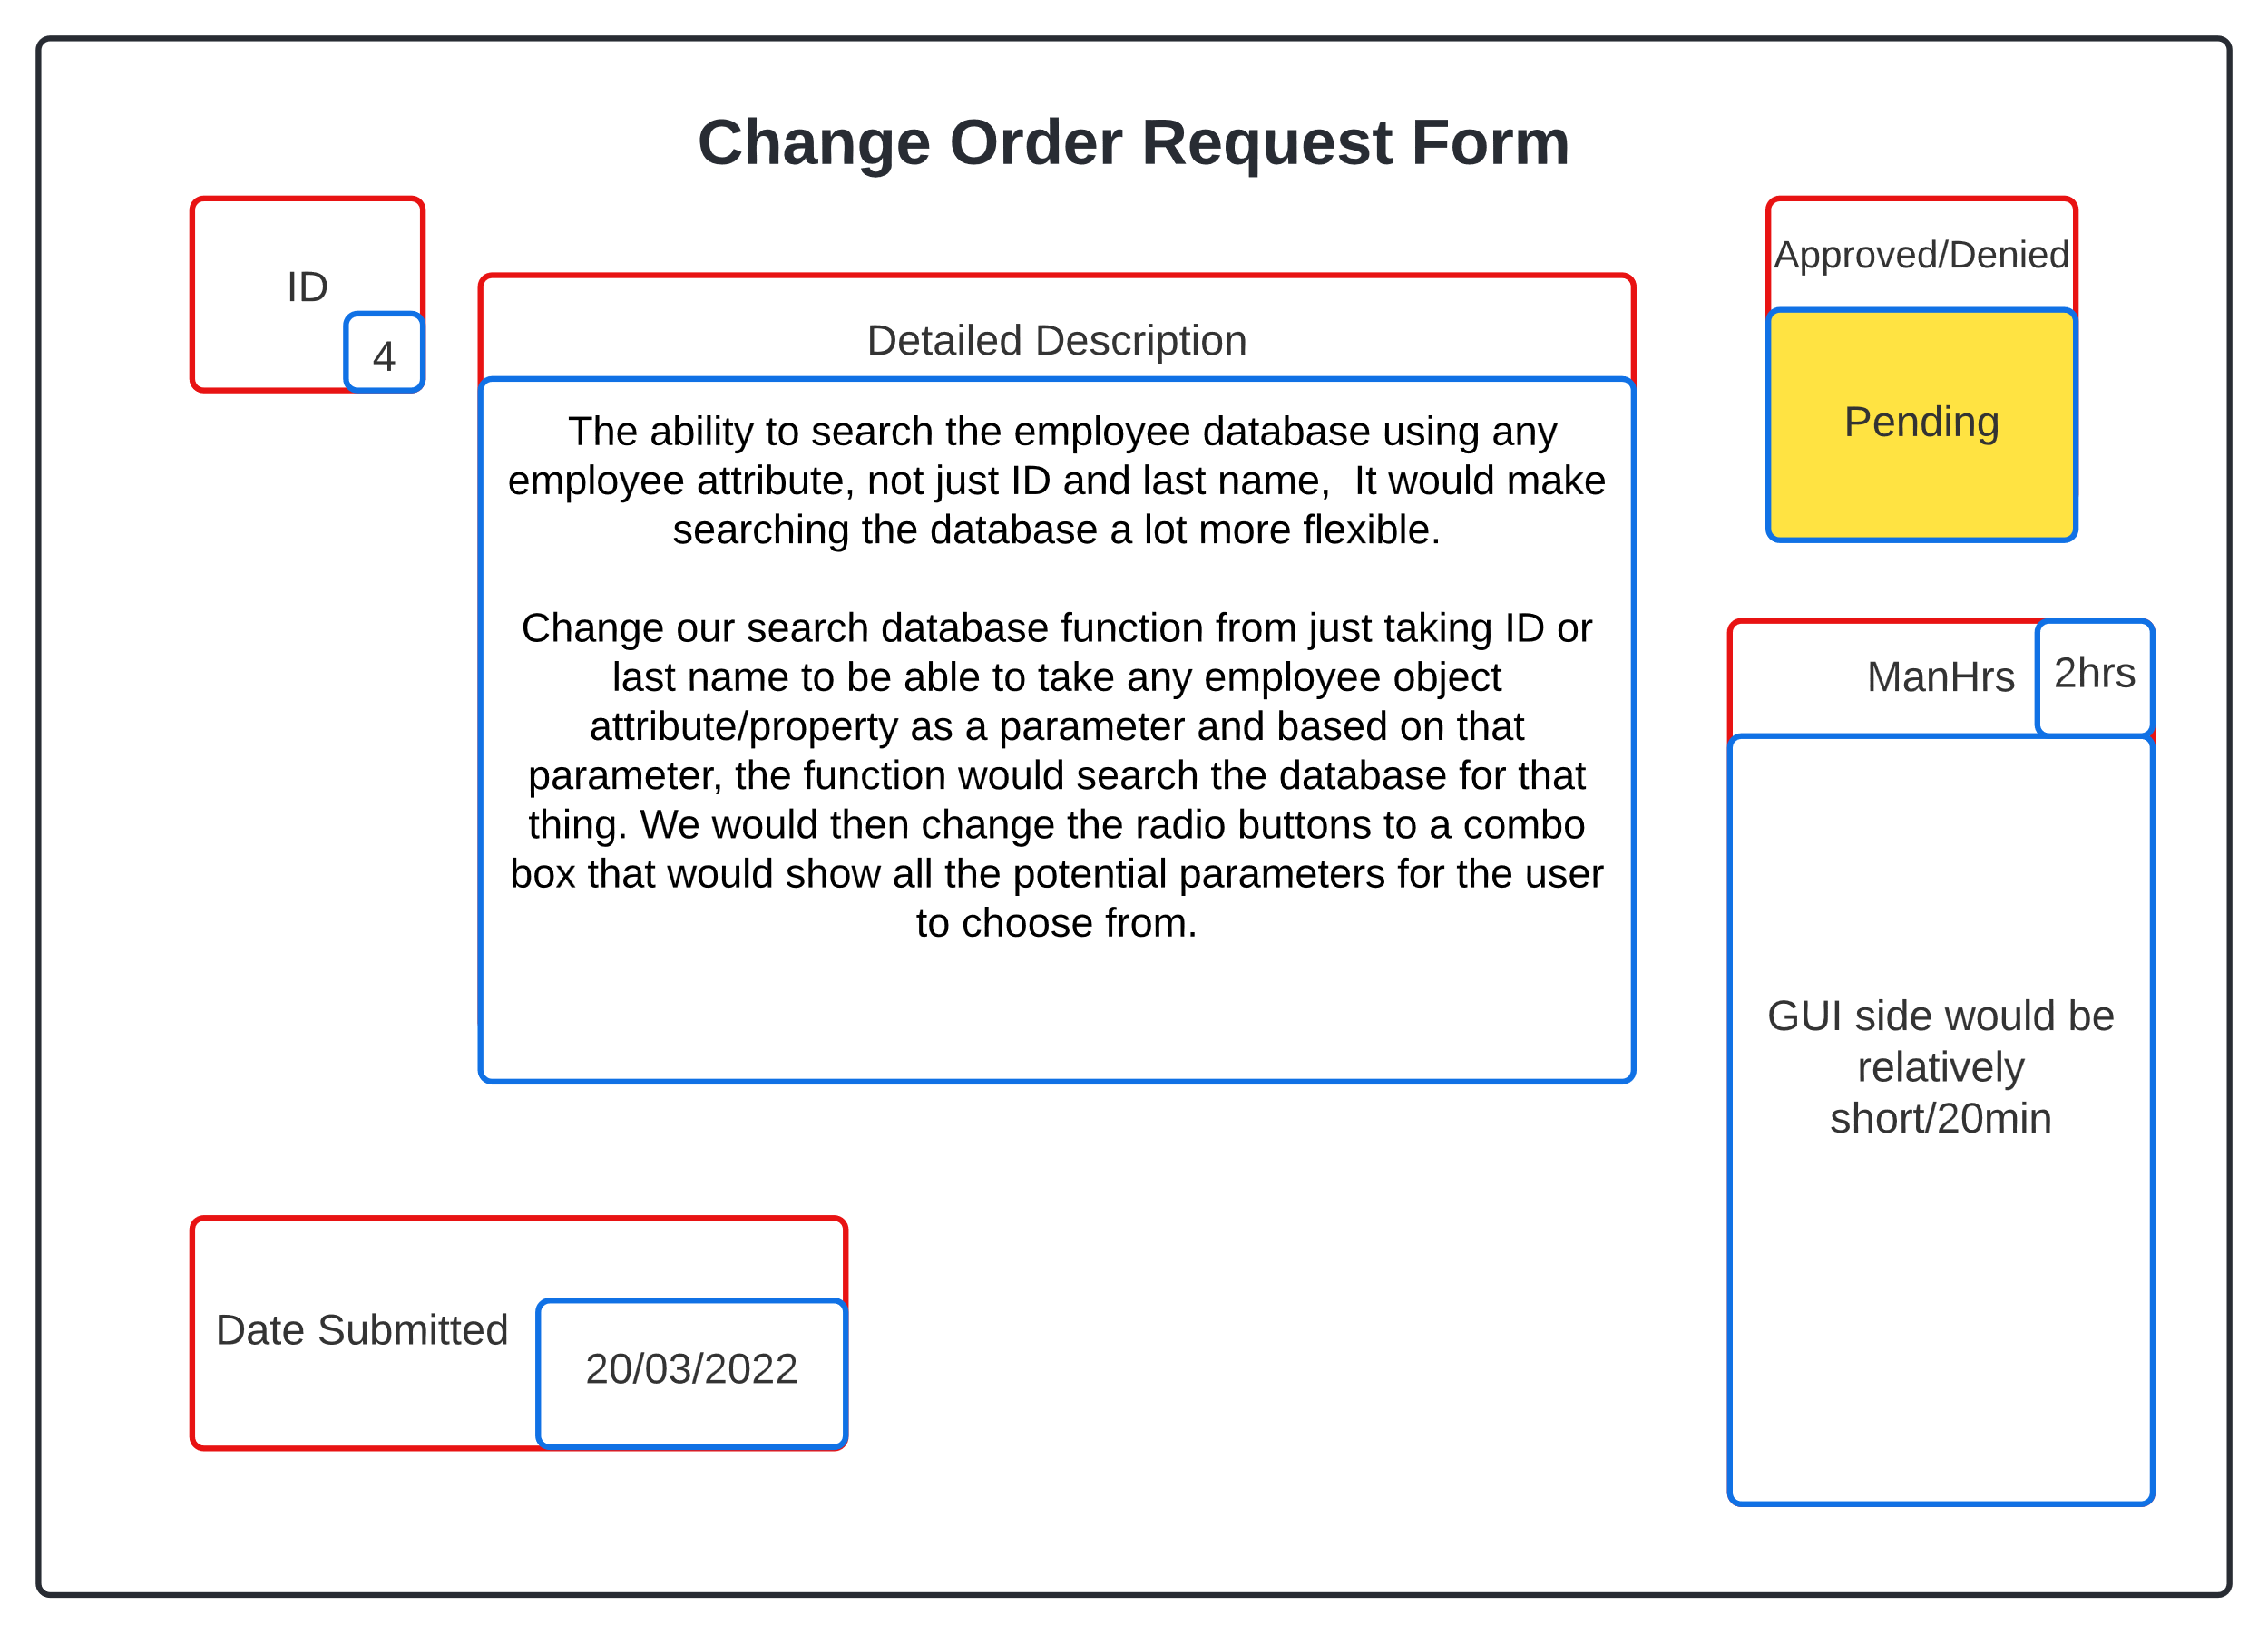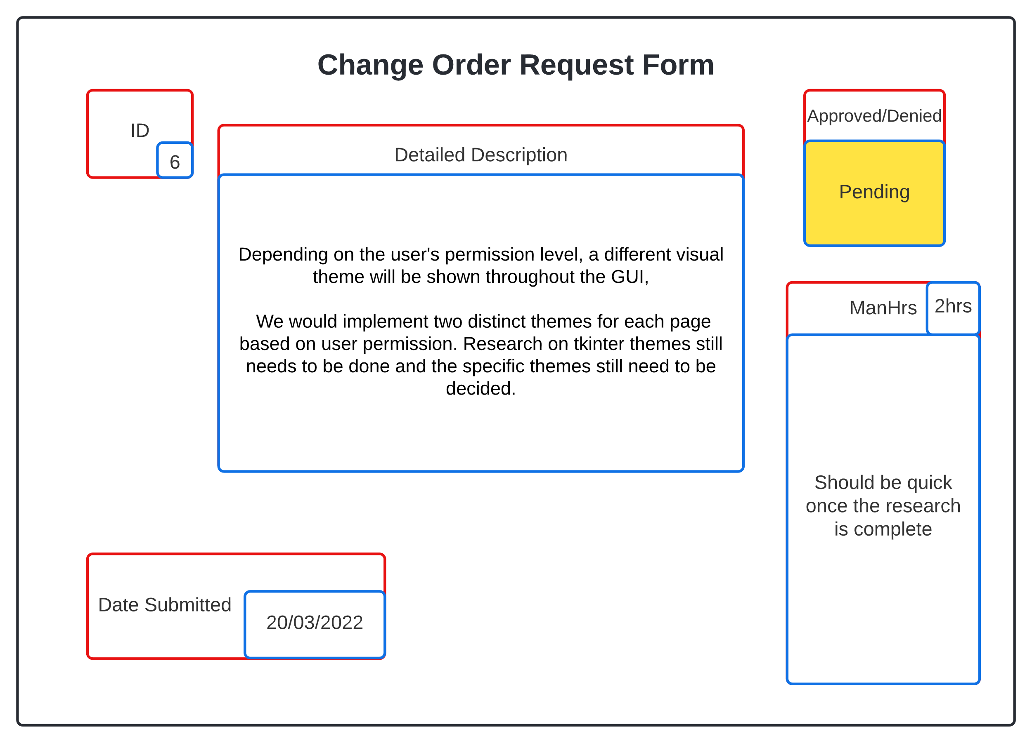

#### User Manual

Summary: This manual is designed to help you get started using the EmpDat program and will describe how to use some of its most basic features.

In this manual, you will learn how to:

* Install Python (required to run application!)
* Login using your employee ID and password
* Navigate the user interface
* Search employees in the database
* Edit employee information
* Add/deactivate employees
* Issue payroll information

***Note: Both adding/deactivating employees and issuing payroll information requires administrator privileges.***

You may refer to this user manual at any time by clicking the “Help” button on the main view page.

1: Installing Python

The first step is to install Python onto your computer. If you already have Python installed, then you may skip this step. To install Python, go to the following website:

<https://www.python.org/>.

Once you are on this page, click on the “Downloads” link and you will be taken to a page which contains all the different Python versions to install. Download the latest version of Python and select the Windows 10 option.

(Image of python website homepage)

(Image of python downloads page)

2: User Login

Once you have successfully installed Python and have started the application, you will be taken to the user login page. Here, you will enter your employee ID number and password into the provided fields. Next, click on the “Enter” button and the application will search for your information. If either the ID number or password are incorrect, an error message will appear to notify you that your information is invalid.

(Image of Login screen)

3: Navigating User Interface

Once you have successfully logged in, you will be brought to the main homepage where all your public employee information is displayed (It is worth mentioning that both you and your peers can view the information on your view page). On the left-hand side of the view page, you will see three buttons: “Edit Employee”, “Search Employee”, and “Help”. You can select the “Help” button at any time to view this user manual. The other two buttons are covered in the following sections.

(Image of general view page)

4: Searching Employees

If you wish to view another employee’s public information, you can select the “Search Employee” button on the main view page and a new page will appear. In the main section of this new page, you will see a search bar, an “Enter” button, and two search parameter radio buttons. You can search for an employee by typing a search parameter into the search bar and clicking the “Enter” button. Once an employee’s information is matched with the search parameters, that employee’s view page will appear and allow you to view their public information. If you wish to leave this page, you may click the “Return” button on the left-hand side and you will be returned to the main view page.

4.1: Search Employee By ID

There are two methods for searching employees. The first method is to search for an employee’s ID number. First, you must select the radio button labeled “Employee ID” in order for the search to work properly. Now you can type the ID number of the employee you are searching for into the search bar and hit the “Enter” button to begin searching. If the ID number is invalid, the application will notify you and will not provide any results until a valid employee ID is entered.

(Searching employee by their ID)

4.2: Search Employee By Last Name

The other method for searching an employee is to search by their last name. Similar to how you search by employee ID numbers, the “Employee Last Name” radio button must be selected before beginning the search. Once this radio button is selected, you may then begin entering the employee’s last name into the search bar and hit the “Enter” button to begin the search. If there is no such employee with the last name you entered, the program will notify you and no results will appear.

(Search an employee by their last name)

5: Edit An Employee

If you wish to change your employee data, you can select the “Edit Employees” button located on the main view page and the page will refresh. Once this has occurred, you are now able to edit any of your own employee data fields. Once you have made your desired changes, you can select the “Update Employee” button located on the left-hand side of the page and you will be returned to the main view page. If you decide to cancel your changes, you may select “Cancel”, which is located below the “Update Employee” button, and you will be returned to the main view page. Your employee data has now been saved and the results are displayed.

(Edit employee page)

6: Add/Deactivate Employee

If you are an administrator, you have access to additional functions which general employees are not authorized to use. The first of these is adding/dropping employees. You can add an employee by clicking on the “Add Employee” button on the left-hand side of the main view page (if you are given administrator access), and you will be taken to a page similar to the “Edit Employee” page where most data fields are left empty for you to enter a new employee’s data. The exception to these data fields is the starting date for the new employee.

[Add an employee (requires administrative privileges)]

You can also deactivate the employee by clicking the “Deactivate Employee” button and that employee will be flagged as an inactive employee.

[Deactivate an employee (requires administrative privileges)]

7: Running Payroll

Another administrator-specific function is the ability to generate a payroll report of each employee in the system. The run payroll function generates a pay report using data stored in each employee’s profile and exporting the information into a CSV file for your viewing.

(Payroll page)

7.1: Add Receipts

You can also add receipts to a commissioned employee by clicking on the “Add Receipt” button and entering in the amount to store in that receipt. This function adds the receipt to the employee’s record and is displayed when that employee’s receipts are processed in reports.

(Add receipts to a commissioned employee)

7.2: Add Timecards

You, the administrator, are also given permissions to add timecards to any hourly employees that are currently active in the system. To do this, click on the “Add Timecards” button and enter the time you wish to store in that particular time card. Once the “Enter” button is pressed, the time card is added to the specified employee’s record and is displayed when that employee’s timecards are processed in payroll reports.

Remember that this user’s manual can be accessed at any time when using this application by pressing on the “Help” button” in the left-hand side of the main view page!

<Insert image of edit page>

Plans

*SPR-4 Risk Management* *Plan*

Summary: This is the risk management plan that focuses on potential risks on sprint four. It is oriented to risks that we face when writing the code and the finished product.

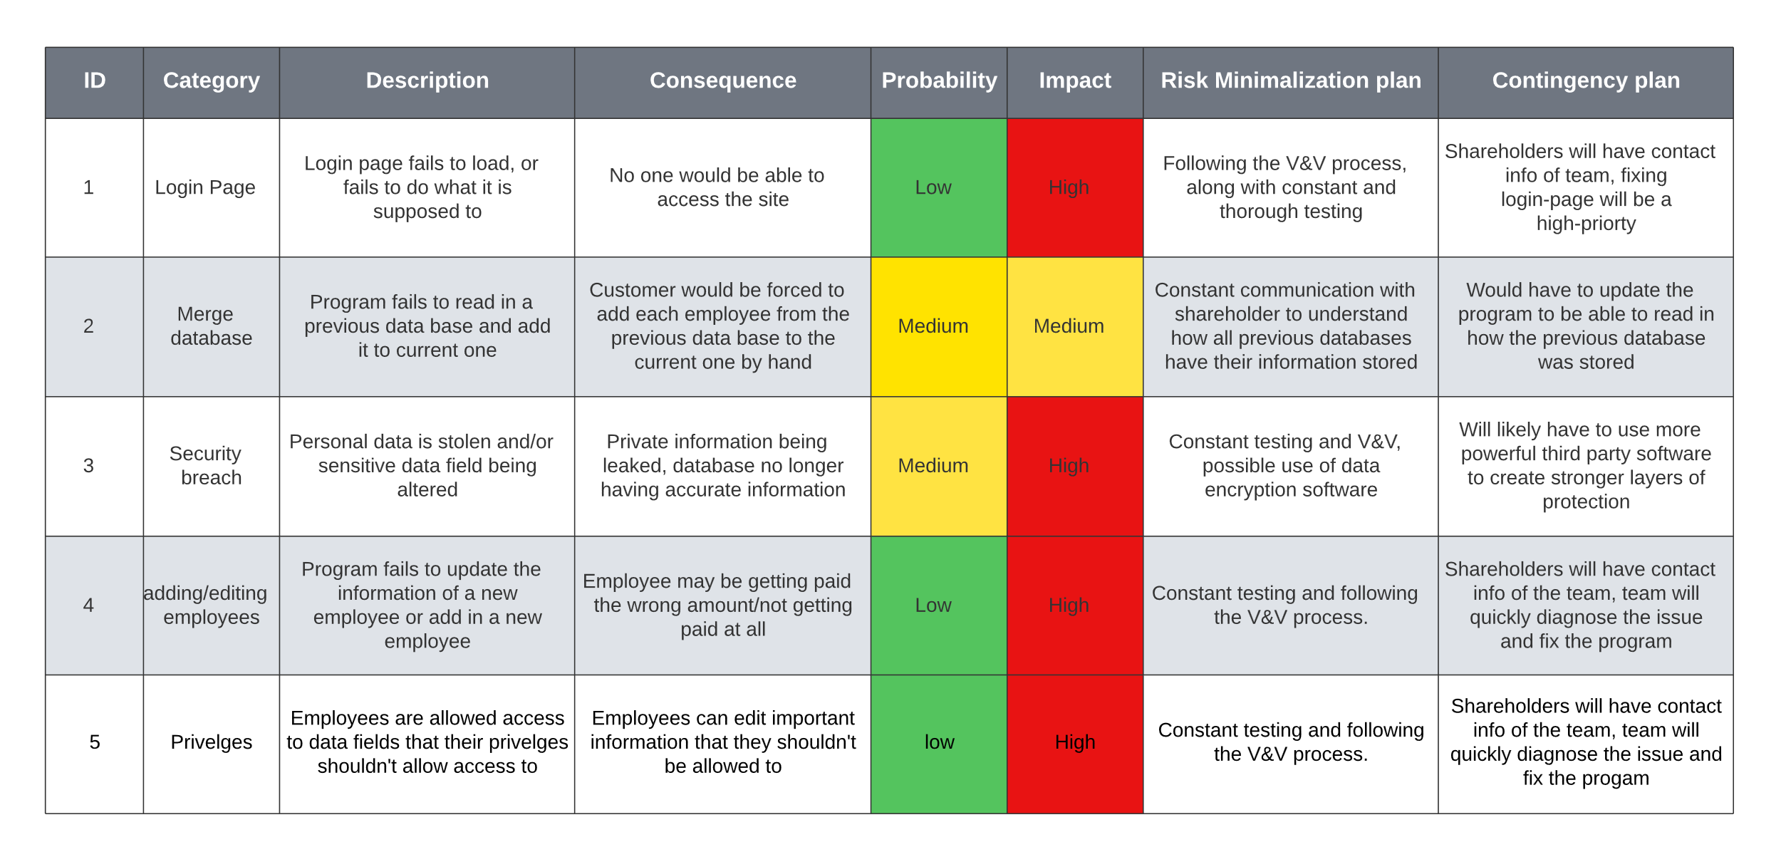

#### Maintenance Plan

Summary: The maintenance for sprint four will be focused on maintaining code through proper testing and V&V as well as reporting bugs and fixing them quickly based on priority.

## Previous Sprint Items

#### GUI Images

Summary: These are images of the GUI that we were missing in the last sprint

Deployment

## Scope

#### Project Justification

Summary: The customer needs a program that can store a database of employees and their relevant information. Along with the ability to add and edit employees in the database and let employees view and edit some of their own information.

#### Product Scope

Summary: We need to deliver a program that uses Tkinter to create the GUI so that the customer has the ability to interact with the database. The GUI needs to have an edit page, view page, add page, and show different information based on whether the employee is and admin or a general user.

#### Acceptance Criteria

Summary: We agree that this is delivered we can run the program through the command line and see the main deliverables. There should be no defects that prevent the main functionality of the product. The program should work as described in the requirements specifications. Customer should provide a sign-off on the final results

#### Deliverables

Summary: list of all of the deliverables that the product will produce

* user manual
* login page
* add employee page
* edit employee page
* view employee page
* pay employee page
* search employee page

#### Assumptions

Summary: uncertainties that haven’t been 100% clarified

* the customer has access to the correct version of python
* the customer will be using windows

## Cutover

#### Staged Development

Summary: We plan on reducing the chance of errors in deployment by using staged deployment. We have a brand-new account created on a surface pro 7 that we will be able to download everything from scratch to see if it works on a device that hasn’t been used for programming before and the exact steps that it’ll take to make it work.

#### Gradual Cutover

Summary: We do NOT plan on applying gradual cutover as our product is small enough that it should be possible to thoroughly test it and safely move every user over to it from the old product.

#### Incremental Deployment

Summary: Incremental deployment would not work with how monolithic application. We would release the entire product at once.

#### Parallel Testing

Summary: It would be relatively easy to apply parallel testing, we would copy the database from the old product and read it into the new one. We would have both systems running for a couple of days, so that we can guarantee that the program works as it should before we remove the old product. It does create additional work for a couple of days for the employees, but it is a safer way to go about deploying the product.

## Deployment Plan

#### Deployment Tasks

Summary: Tasks required to perform a successful deployment

* Hardware – computers with Windows 10 installed
* Documentation – user manual
* Training – explaining to the users how the program works, and making sure they are confident in its use
* Database – ensuring the shareholder’s database is compatible with the new software
* Software – the product that we are creating for the shareholder

#### Rollback Plan

Summary: The plan if our product shows to have glaring functional issues and requires us to reverse our deployment plan, we will simply remove the current version of the product from the user’s computers and have them continue using the old software until fix our software

#### Point of No Return

Summary: After sprint six, we would have reached the point of no return for any major functional errors that would require us to virtually restart development. At that time we have to either decide to push forward with what we have or to scrap the project completely.

Testing

## Testing

#### Test Plan

Summary: Our tests were created through pytest using assertion tests, they tested each page to make sure that they were functional and followed the requirements.

import EmpDat_v5 #code file to test

from employee_v3 import * #code for employee

import pytest #testing framework

from tkinter import ttk

# emp_dict = {}

# emp1 = Employee("1", "Jaden", "Albrecht", "Street", "City", "State", "Zip", "1", "1",

# 100.00, 10.00, 1.00, "Routing Num", "Account Num", "Office Num",

# "Personal Phone", "Office Email", "Personal Email", "Birthday",

# "SSN", False, "Master Manager", "Managing Dept", "1/1/22", None, True,

# "test")

# emp2 = Employee("2", "Cody", "Strange", "Street", "City", "State", "Zip", "2", "2",

# 100.00, 10.00, 1.00, "Routing Num", "Account Num", "Office Num",

# "Personal Phone", "Office Email", "Personal Email", "Birthday",

# "SSN", False, "Super Scribe", "Writing Dept", "1/1/22", None, True,

# "test")

# emp3 = Employee("3", "Tyler", "Deschamp", "Street", "City", "State", "Zip", "3", "1",

# 100.00, 10.00, 1.00, "Routing Num", "Account Num", "Office Num",

# "Personal Phone", "Office Email", "Personal Email", "Birthday",

# "SSN", False, "Chart Champion", "Documenting Dept", "1/1/22", None, True,

# "test")

# emp4 = Employee("4", "Jordan", "Van Patten", "Street", "City", "State", "Zip", "1", "2",

# 100.00, 10.00, 1.00, "Routing Num", "Account Num", "Office Num",

# "Personal Phone", "Office Email", "Personal Email", "Birthday",

# "SSN", False, "Triumphant Tester", "Testing Dept", "1/1/22", None, True,

# "test")

# emp5 = Employee("5", "Ethan", "Taylor", "Street", "City", "State", "Zip", "2", "1",

# 100.00, 10.00, 1.00, "Routing Num", "Account Num", "Office Num",

# "Personal Phone", "Office Email", "Personal Email", "Birthday",

# "SSN", True, "GUI Guy", "GUI Dept", "1/1/22", None, True,

# "test")

# emp6 = Employee("6", "Etha", "Taylor", "Street", "City", "State", "Zip", "2", "1",

# 100.00, 10.00, 1.00, "Routing Num", "Account Num", "Office Num",

# "Personal Phone", "Office Email", "Personal Email", "Birthday",

# "SSN", True, "GUI Guy", "GUI Dept", "1/1/22", None, True,

# "test")

# emp7 = Employee("7", "Eth", "Taylor", "Street", "City", "State", "Zip", "2", "1",

# 100.00, 10.00, 1.00, "Routing Num", "Account Num", "Office Num",

# "Personal Phone", "Office Email", "Personal Email", "Birthday",

# "SSN", True, "GUI Guy", "GUI Dept", "1/1/22", None, True,

# "test")

# emp8 = Employee("8", "Et", "Taylor", "Street", "City", "State", "Zip", "2", "1",

# 100.00, 10.00, 1.00, "Routing Num", "Account Num", "Office Num",

# "Personal Phone", "Office Email", "Personal Email", "Birthday",

# "SSN", True, "GUI Guy", "GUI Dept", "1/1/22", None, True,

# "test")

# emp_dict[emp1.get_id()] = emp1

# emp_dict[emp2.get_id()] = emp2

# emp_dict[emp3.get_id()] = emp3

# emp_dict[emp4.get_id()] = emp4

# emp_dict[emp5.get_id()] = emp5

# emp_dict[emp6.get_id()] = emp6

# emp_dict[emp7.get_id()] = emp7

# emp_dict[emp8.get_id()] = emp8

# x = EmpDat_v5.EmpApp(emp_dict)

emps = get_db("database/employees.json")

emp_dict = {}

for emp in emps:

emp_dict[str(emp["id"])] = Employee(str(emp["id"]), emp["first_name"], emp["last_name"], emp["address"], emp["city"],

emp["state"] ,emp["zip"], emp["classification"], emp["pay_method"], emp["salary"],

emp["commission"], emp["hourly"], emp["routing_num"], emp["account_num"],

emp["office_phone"], emp["personal_phone"], emp["office_email"], emp["personal_email"],

emp["dob"], emp["ssn"], emp["admin"], emp["title"], emp["dept"], emp["start"],

emp["end"], emp["status"], emp["password"])

x = EmpDat_v5.EmpApp(emp_dict)

#CODE FOR TESTING LOGIN (Validate user class only)

def test_correct_1():

#code that should pass username and password

x.username.set("8")

x.user_pass.set("test")

x.validate_user()

assert x.msg.get() != ("Invalid ID!") and ("Incorrect password or ID!") != x.msg.get()

def test_correct_2():

x.username.set("2")

x.user_pass.set("test")

x.validate_user()

assert x.msg.get() != ("Invalid ID!") and ("Incorrect password or ID!") != x.msg.get()

def test_correct_3():

x.username.set("3")

x.user_pass.set("test")

x.validate_user()

assert ("Invalid ID!") != x.msg.get() and ("Incorrect password or ID!") != x.msg.get()

def test_correct_4():

x.username.set("4")

x.user_pass.set("test")

x.validate_user()

assert ("Invalid ID!") != x.msg.get() and ("Incorrect password or ID!") != x.msg.get()

def test_correct_5():

x.username.set("5")

x.user_pass.set("test")

x.validate_user()

assert ("Invalid ID!") != x.msg.get() and ("Incorrect password or ID!") != x.msg.get()

def test_correct_6():

x.username.set("6")

x.user_pass.set("test")

x.validate_user()

assert ("Invalid ID!") != x.msg.get() and ("Incorrect password or ID!") != x.msg.get()

def test_correct_7():

x.username.set("7")

x.user_pass.set("test")

x.validate_user()

assert ("Invalid ID!") != x.msg.get() and ("Incorrect password or ID!") != x.msg.get()

#code testing for incorrect usernames but correct passwords

def test_incorrect_1():

x.username.set("jim")

x.user_pass.set("test")

x.validate_user()

assert ("Invalid ID!") == x.msg.get() or ("Incorrect password or ID!") == x.msg.get()

def test_incorrect_2():

x.username.set("tony")

x.user_pass.set("test")

x.validate_user()

assert ("Invalid ID!") == x.msg.get() or ("Incorrect password or ID!") == x.msg.get()

def test_incorrect_3():

x.username.set("123")

x.user_pass.set("test")

x.validate_user()

assert ("Invalid ID!") == x.msg.get() or ("Incorrect password or ID!") == x.msg.get()

def test_incorrect_4():

x.username.set("57")

x.user_pass.set("test")

x.validate_user()

assert ("Invalid ID!") == x.msg.get() or ("Incorrect password or ID!") == x.msg.get()

def test_incorrect_5():

x.username.set("gfad")

x.user_pass.set("test")

x.validate_user()

assert ("Invalid ID!") == x.msg.get() or ("Incorrect password or ID!") == x.msg.get()

def test_incorrect_6():

x.username.set("wrong")

x.user_pass.set("test")

x.validate_user()

assert ("Invalid ID!") == x.msg.get() or ("Incorrect password or ID!") == x.msg.get()

def test_incorrect_7():

x.username.set("almost")

x.user_pass.set("test")

x.validate_user()

assert ("Invalid ID!") == x.msg.get() or ("Incorrect password or ID!") == x.msg.get()

def test_incorrect_8():

x.username.set("so close")

x.user_pass.set("test")

x.validate_user()

assert ("Invalid ID!") == x.msg.get() or ("Incorrect password or ID!") == x.msg.get()

#code that tests for incorrect passwords, but correct username

def test_incorrectP_1():

x.username.set("1")

x.user_pass.set("tests")

x.validate_user()

assert ("Invalid ID!") == x.msg.get() or ("Incorrect password or ID!") == x.msg.get()

def test_incorrectP_2():

x.username.set("1")

x.user_pass.set("test!")

x.validate_user()

assert ("Invalid ID!") == x.msg.get() or ("Incorrect password or ID!") == x.msg.get()

def test_incorrectP_3():

x.username.set("1")

x.user_pass.set("tesT")

x.validate_user()

assert ("Invalid ID!") == x.msg.get() or ("Incorrect password or ID!") == x.msg.get()

def test_incorrectP_4():

x.username.set("1")

x.user_pass.set("Test")

x.validate_user()

assert ("Invalid ID!") == x.msg.get() or ("Incorrect password or ID!") == x.msg.get()

def test_incorrectP_5():

x.username.set("1")

x.user_pass.set("nope")

x.validate_user()

assert ("Invalid ID!") == x.msg.get() or ("Incorrect password or ID!") == x.msg.get()

def test_incorrectP_6():

x.username.set("1")

x.user_pass.set("tESt")

x.validate_user()

assert ("Invalid ID!") == x.msg.get() or ("Incorrect password or ID!") == x.msg.get()

def test_incorrectP_7():

x.username.set("1")

x.user_pass.set("password")

x.validate_user()

assert ("Invalid ID!") == x.msg.get() or ("Incorrect password or ID!") == x.msg.get()

def test_incorrectP_8():

x.username.set("1")

x.user_pass.set("letMeIn")

x.validate_user()

assert ("Invalid ID!") == x.msg.get() or ("Incorrect password or ID!") == x.msg.get()

def test_incorrectP_9():

x.username.set("1")

x.user_pass.set("please")

x.validate_user()

assert ("Invalid ID!") == x.msg.get() or ("Incorrect password or ID!") == x.msg.get()

def test_incorrectP_10():

x.username.set("1")

x.user_pass.set("prettyplease")

x.validate_user()

assert ("Invalid ID!") == x.msg.get() or ("Incorrect password or ID!") == x.msg.get()

def test_incorrectP_11():

x.username.set("1")

x.user_pass.set("123456")

x.validate_user()

assert ("Invalid ID!") == x.msg.get() or ("Incorrect password or ID!") == x.msg.get()

#CODE FOR TESTING VIEW PAGE

def test_nonAdminPass_1():

x.username.set("8")

x.user_pass.set("test")

x.validate_user()

v = EmpDat_v5.View_Page(parent=x.container, controller=x)

if (emp_dict[x.username.get()].is_admin() == True):

assert v.permission.get() == '1'

else:

assert v.permission.get() == '2'

assert v.id.get() == emp_dict[x.username.get()].get_id()

assert v.f_name.get() == emp_dict[x.username.get()].get_first_name()

assert v.l_name.get() == emp_dict[x.username.get()].get_last_name()

assert v.street.get() == emp_dict[x.username.get()].get_address()

assert v.city.get() == emp_dict[x.username.get()].get_city()

assert v.emp_state.get() == emp_dict[x.username.get()].get_state()

assert v.zip.get() == emp_dict[x.username.get()].get_zip()

assert v.classification.get() == emp_dict[x.username.get()].get_class()

assert v.hourly.get() == str(emp_dict[x.username.get()].get_hourly_rate())

assert v.commissioned.get() == str(emp_dict[x.username.get()].get_commission_rate())

assert v.salary.get() == str(emp_dict[x.username.get()].get_salary())

assert v.o_phone.get() == emp_dict[x.username.get()].get_office_phone()

assert v.o_email.get() == emp_dict[x.username.get()].get_office_email()

assert v.p_phone.get() == emp_dict[x.username.get()].get_personal_phone()

assert v.p_email.get() == emp_dict[x.username.get()].get_personal_email()

assert v.dob.get() == emp_dict[x.username.get()].get_dob()

assert v.ssn.get() == emp_dict[x.username.get()].get_ssn()

assert v.pay_type.get() == emp_dict[x.username.get()].get_pay_method()

assert v.routing_num.get() == emp_dict[x.username.get()].get_routing()

assert v.account_entry.get() == emp_dict[x.username.get()].get_account()

assert v.emp_title.get() == emp_dict[x.username.get()].get_title()

assert v.emp_dept.get() == emp_dict[x.username.get()].get_dept()

assert v.start_date.get() == emp_dict[x.username.get()].get_start()

assert v.end_date.get() == str(emp_dict[x.username.get()].get_end())

if (emp_dict[x.username.get()].get_status() == True):

assert v.emp_status.get() == "Active"

else:

assert v.emp_status.get() == "Deactivated"

def test_nonAdminPass_2():

x.username.set("2")

x.user_pass.set("test")

x.validate_user()

v = EmpDat_v5.View_Page(parent=x.container, controller=x)

if (emp_dict[x.username.get()].is_admin() == True):

assert v.permission.get() == '1'

else:

assert v.permission.get() == '2'

assert v.id.get() == emp_dict[x.username.get()].get_id()

assert v.f_name.get() == emp_dict[x.username.get()].get_first_name()

assert v.l_name.get() == emp_dict[x.username.get()].get_last_name()

assert v.street.get() == emp_dict[x.username.get()].get_address()

assert v.city.get() == emp_dict[x.username.get()].get_city()

assert v.emp_state.get() == emp_dict[x.username.get()].get_state()

assert v.zip.get() == emp_dict[x.username.get()].get_zip()

assert v.classification.get() == emp_dict[x.username.get()].get_class()

assert v.hourly.get() == str(emp_dict[x.username.get()].get_hourly_rate())

assert v.commissioned.get() == str(emp_dict[x.username.get()].get_commission_rate())

assert v.salary.get() == str(emp_dict[x.username.get()].get_salary())

assert v.o_phone.get() == emp_dict[x.username.get()].get_office_phone()

assert v.o_email.get() == emp_dict[x.username.get()].get_office_email()

assert v.p_phone.get() == emp_dict[x.username.get()].get_personal_phone()

assert v.p_email.get() == emp_dict[x.username.get()].get_personal_email()

assert v.dob.get() == emp_dict[x.username.get()].get_dob()

assert v.ssn.get() == emp_dict[x.username.get()].get_ssn()

assert v.pay_type.get() == emp_dict[x.username.get()].get_pay_method()

assert v.routing_num.get() == emp_dict[x.username.get()].get_routing()

assert v.account_entry.get() == emp_dict[x.username.get()].get_account()

assert v.emp_title.get() == emp_dict[x.username.get()].get_title()

assert v.emp_dept.get() == emp_dict[x.username.get()].get_dept()

assert v.start_date.get() == emp_dict[x.username.get()].get_start()

assert v.end_date.get() == str(emp_dict[x.username.get()].get_end())

if (emp_dict[x.username.get()].get_status() == True):

assert v.emp_status.get() == "Active"

else:

assert v.emp_status.get() == "Deactivated"

def test_nonAdminPass_3():

x.username.set("3")

x.user_pass.set("test")

x.validate_user()

v = EmpDat_v5.View_Page(parent=x.container, controller=x)

if (emp_dict[x.username.get()].is_admin() == True):

assert v.permission.get() == '1'

else:

assert v.permission.get() == '2'

assert v.id.get() == emp_dict[x.username.get()].get_id()

assert v.f_name.get() == emp_dict[x.username.get()].get_first_name()

assert v.l_name.get() == emp_dict[x.username.get()].get_last_name()

assert v.street.get() == emp_dict[x.username.get()].get_address()

assert v.city.get() == emp_dict[x.username.get()].get_city()

assert v.emp_state.get() == emp_dict[x.username.get()].get_state()

assert v.zip.get() == emp_dict[x.username.get()].get_zip()

assert v.classification.get() == emp_dict[x.username.get()].get_class()

assert v.hourly.get() == str(emp_dict[x.username.get()].get_hourly_rate())

assert v.commissioned.get() == str(emp_dict[x.username.get()].get_commission_rate())

assert v.salary.get() == str(emp_dict[x.username.get()].get_salary())

assert v.o_phone.get() == emp_dict[x.username.get()].get_office_phone()

assert v.o_email.get() == emp_dict[x.username.get()].get_office_email()

assert v.p_phone.get() == emp_dict[x.username.get()].get_personal_phone()

assert v.p_email.get() == emp_dict[x.username.get()].get_personal_email()

assert v.dob.get() == emp_dict[x.username.get()].get_dob()

assert v.ssn.get() == emp_dict[x.username.get()].get_ssn()

assert v.pay_type.get() == emp_dict[x.username.get()].get_pay_method()

assert v.routing_num.get() == emp_dict[x.username.get()].get_routing()

assert v.account_entry.get() == emp_dict[x.username.get()].get_account()

assert v.emp_title.get() == emp_dict[x.username.get()].get_title()

assert v.emp_dept.get() == emp_dict[x.username.get()].get_dept()

assert v.start_date.get() == emp_dict[x.username.get()].get_start()

assert v.end_date.get() == str(emp_dict[x.username.get()].get_end())

if (emp_dict[x.username.get()].get_status() == True):

assert v.emp_status.get() == "Active"

else:

assert v.emp_status.get() == "Deactivated"

def test_nonAdminPass_4():

x.username.set("4")

x.user_pass.set("test")

x.validate_user()

v = EmpDat_v5.View_Page(parent=x.container, controller=x)

if (emp_dict[x.username.get()].is_admin() == True):

assert v.permission.get() == '1'

else:

assert v.permission.get() == '2'

assert v.id.get() == emp_dict[x.username.get()].get_id()

assert v.f_name.get() == emp_dict[x.username.get()].get_first_name()

assert v.l_name.get() == emp_dict[x.username.get()].get_last_name()

assert v.street.get() == emp_dict[x.username.get()].get_address()

assert v.city.get() == emp_dict[x.username.get()].get_city()

assert v.emp_state.get() == emp_dict[x.username.get()].get_state()

assert v.zip.get() == emp_dict[x.username.get()].get_zip()

assert v.classification.get() == emp_dict[x.username.get()].get_class()

assert v.hourly.get() == str(emp_dict[x.username.get()].get_hourly_rate())

assert v.commissioned.get() == str(emp_dict[x.username.get()].get_commission_rate())

assert v.salary.get() == str(emp_dict[x.username.get()].get_salary())

assert v.o_phone.get() == emp_dict[x.username.get()].get_office_phone()

assert v.o_email.get() == emp_dict[x.username.get()].get_office_email()

assert v.p_phone.get() == emp_dict[x.username.get()].get_personal_phone()

assert v.p_email.get() == emp_dict[x.username.get()].get_personal_email()

assert v.dob.get() == emp_dict[x.username.get()].get_dob()

assert v.ssn.get() == emp_dict[x.username.get()].get_ssn()

assert v.pay_type.get() == emp_dict[x.username.get()].get_pay_method()

assert v.routing_num.get() == emp_dict[x.username.get()].get_routing()

assert v.account_entry.get() == emp_dict[x.username.get()].get_account()

assert v.emp_title.get() == emp_dict[x.username.get()].get_title()

assert v.emp_dept.get() == emp_dict[x.username.get()].get_dept()

assert v.start_date.get() == emp_dict[x.username.get()].get_start()

assert v.end_date.get() == str(emp_dict[x.username.get()].get_end())

if (emp_dict[x.username.get()].get_status() == True):

assert v.emp_status.get() == "Active"

else:

assert v.emp_status.get() == "Deactivated"

def test_AdminPass_1():

x.username.set("8")

x.user_pass.set("test")

x.validate_user()

v = EmpDat_v5.View_Page(parent=x.container, controller=x)

if (emp_dict[x.username.get()].is_admin() == True):

assert v.permission.get() == '1'

else:

assert v.permission.get() == '2'

assert v.id.get() == emp_dict[x.username.get()].get_id()

assert v.f_name.get() == emp_dict[x.username.get()].get_first_name()

assert v.l_name.get() == emp_dict[x.username.get()].get_last_name()

assert v.street.get() == emp_dict[x.username.get()].get_address()

assert v.city.get() == emp_dict[x.username.get()].get_city()

assert v.emp_state.get() == emp_dict[x.username.get()].get_state()

assert v.zip.get() == emp_dict[x.username.get()].get_zip()

assert v.classification.get() == emp_dict[x.username.get()].get_class()

assert v.hourly.get() == str(emp_dict[x.username.get()].get_hourly_rate())

assert v.commissioned.get() == str(emp_dict[x.username.get()].get_commission_rate())

assert v.salary.get() == str(emp_dict[x.username.get()].get_salary())

assert v.o_phone.get() == emp_dict[x.username.get()].get_office_phone()

assert v.o_email.get() == emp_dict[x.username.get()].get_office_email()

assert v.p_phone.get() == emp_dict[x.username.get()].get_personal_phone()

assert v.p_email.get() == emp_dict[x.username.get()].get_personal_email()

assert v.dob.get() == emp_dict[x.username.get()].get_dob()

assert v.ssn.get() == emp_dict[x.username.get()].get_ssn()

assert v.pay_type.get() == emp_dict[x.username.get()].get_pay_method()

assert v.routing_num.get() == emp_dict[x.username.get()].get_routing()

assert v.account_entry.get() == emp_dict[x.username.get()].get_account()

assert v.emp_title.get() == emp_dict[x.username.get()].get_title()

assert v.emp_dept.get() == emp_dict[x.username.get()].get_dept()

assert v.start_date.get() == emp_dict[x.username.get()].get_start()

assert v.end_date.get() == str(emp_dict[x.username.get()].get_end())

if (emp_dict[x.username.get()].get_status() == True):

assert v.emp_status.get() == "Active"

else:

assert v.emp_status.get() == "Deactivated"

def test_AdminPass_2():

x.username.set("6")

x.user_pass.set("test")

x.validate_user()

v = EmpDat_v5.View_Page(parent=x.container, controller=x)

if (emp_dict[x.username.get()].is_admin() == True):

assert v.permission.get() == '1'

else:

assert v.permission.get() == '2'

assert v.id.get() == emp_dict[x.username.get()].get_id()

assert v.f_name.get() == emp_dict[x.username.get()].get_first_name()

assert v.l_name.get() == emp_dict[x.username.get()].get_last_name()

assert v.street.get() == emp_dict[x.username.get()].get_address()

assert v.city.get() == emp_dict[x.username.get()].get_city()

assert v.emp_state.get() == emp_dict[x.username.get()].get_state()

assert v.zip.get() == emp_dict[x.username.get()].get_zip()

assert v.classification.get() == emp_dict[x.username.get()].get_class()

assert v.hourly.get() == str(emp_dict[x.username.get()].get_hourly_rate())

assert v.commissioned.get() == str(emp_dict[x.username.get()].get_commission_rate())

assert v.salary.get() == str(emp_dict[x.username.get()].get_salary())

assert v.o_phone.get() == emp_dict[x.username.get()].get_office_phone()

assert v.o_email.get() == emp_dict[x.username.get()].get_office_email()

assert v.p_phone.get() == emp_dict[x.username.get()].get_personal_phone()

assert v.p_email.get() == emp_dict[x.username.get()].get_personal_email()

assert v.dob.get() == emp_dict[x.username.get()].get_dob()

assert v.ssn.get() == emp_dict[x.username.get()].get_ssn()

assert v.pay_type.get() == emp_dict[x.username.get()].get_pay_method()

assert v.routing_num.get() == emp_dict[x.username.get()].get_routing()

assert v.account_entry.get() == emp_dict[x.username.get()].get_account()

assert v.emp_title.get() == emp_dict[x.username.get()].get_title()

assert v.emp_dept.get() == emp_dict[x.username.get()].get_dept()

assert v.start_date.get() == emp_dict[x.username.get()].get_start()

assert v.end_date.get() == str(emp_dict[x.username.get()].get_end())

if (emp_dict[x.username.get()].get_status() == True):

assert v.emp_status.get() == "Active"

else:

assert v.emp_status.get() == "Deactivated"

#CODE FOR TESTING EDIT PAGE

def test_edit_1():

x.username.set("8")

x.user_pass.set("test")

x.validate_user()

v = EmpDat_v5.View_Page(parent=x.container, controller=x)

e = EmpDat_v5.Edit_Page(v, controller=x)

e.f_name.set("FirstNameChanged")

e.l_name.set("LastNameChanged")

e.street.set("StreetChanged")

e.city.set("CityChanged")

e.zip.set("ZIPChanged")

e.classification.set("2")

e.pay_type.set("1")

e.salary.set("100.00")

e.commissioned.set("10.00")

e.hourly.set("1.00")

e.routing_num.set("RoutingChanged")

e.account_num.set("AccountChanged")

e.o_phone.set("OfficePChanged")

e.p_phone.set("PersonalPChanged")

e.o_email.set("OfficeEChanged")

e.p_email.set("PersonalEChanged")

e.dob.set("BirthdayChanged")

e.ssn.set("SSNChanged")

e.emp_title.set("MasterChanged")

e.emp_dept.set("DeptChanged")

e.start_date.set("1/2/2022")

e.update_emp()

if (emp_dict[x.username.get()].is_admin() == True):

assert v.permission.get() == '1'

else:

assert v.permission.get() == '2'

assert emp_dict[x.username.get()].get_first_name() == "FirstNameChanged"

assert emp_dict[x.username.get()].get_last_name() == "LastNameChanged"

assert emp_dict[x.username.get()].get_address() == "StreetChanged"

assert emp_dict[x.username.get()].get_city() == "CityChanged"

assert emp_dict[x.username.get()].get_zip() == "ZIPChanged"

assert emp_dict[x.username.get()].get_class() == "2"

assert str(emp_dict[x.username.get()].get_hourly_rate()) == "1.00"

assert str(emp_dict[x.username.get()].get_commission_rate()) == "10.00"

assert str(emp_dict[x.username.get()].get_salary()) == "100.00"

assert emp_dict[x.username.get()].get_office_phone() == "OfficePChanged"

assert emp_dict[x.username.get()].get_office_email() == "OfficeEChanged"

assert emp_dict[x.username.get()].get_personal_phone() == "PersonalPChanged"

assert emp_dict[x.username.get()].get_personal_email() == "PersonalEChanged"

assert emp_dict[x.username.get()].get_dob() == "BirthdayChanged"

assert emp_dict[x.username.get()].get_ssn() == "SSNChanged"

assert emp_dict[x.username.get()].get_pay_method() == "1"

assert emp_dict[x.username.get()].get_routing() == "RoutingChanged"

assert emp_dict[x.username.get()].get_account() == "AccountChanged"

assert emp_dict[x.username.get()].get_title() == "MasterChanged"

assert emp_dict[x.username.get()].get_dept() == "DeptChanged"

assert emp_dict[x.username.get()].get_start() == "1/2/2022"

if (emp_dict[x.username.get()].get_status() == True):

assert e.emp_status.get() == "Active"

else:

assert e.emp_status.get() == "Deactivated"

def test_edit_2():

x.username.set("8")

x.user_pass.set("test")

x.validate_user()

v = EmpDat_v5.View_Page(parent=x.container, controller=x)

e = EmpDat_v5.Edit_Page(v, controller=x)

e.f_name.set("FirstNameChanged")

e.l_name.set("LastNameChanged")

e.street.set("StreetChanged")

e.city.set("CityChanged")

e.zip.set("ZIPChanged")

e.classification.set("2")

e.pay_type.set("1")

e.salary.set("100.00")

e.commissioned.set("10.00")

e.hourly.set("1.00")

e.routing_num.set("RoutingChanged")

e.account_num.set("AccountChanged")

e.o_phone.set("OfficePChanged")

e.p_phone.set("PersonalPChanged")

e.o_email.set("OfficeEChanged")

e.p_email.set("PersonalEChanged")

e.dob.set("BirthdayChanged")

e.ssn.set("SSNChanged")

e.emp_title.set("MasterChanged")

e.emp_dept.set("DeptChanged")

e.start_date.set("1/2/2022")

e.update_emp()

if (emp_dict[x.username.get()].is_admin() == True):

assert v.permission.get() == '1'

else:

assert v.permission.get() == '2'

assert emp_dict[x.username.get()].get_first_name() == "FirstNameChanged"

assert emp_dict[x.username.get()].get_last_name() == "LastNameChanged"

assert emp_dict[x.username.get()].get_address() == "StreetChanged"

assert emp_dict[x.username.get()].get_city() == "CityChanged"

assert emp_dict[x.username.get()].get_zip() == "ZIPChanged"

assert emp_dict[x.username.get()].get_class() == "2"

assert str(emp_dict[x.username.get()].get_hourly_rate()) == "1.00"

assert str(emp_dict[x.username.get()].get_commission_rate()) == "10.00"

assert str(emp_dict[x.username.get()].get_salary()) == "100.00"

assert emp_dict[x.username.get()].get_office_phone() == "OfficePChanged"

assert emp_dict[x.username.get()].get_office_email() == "OfficeEChanged"

assert emp_dict[x.username.get()].get_personal_phone() == "PersonalPChanged"

assert emp_dict[x.username.get()].get_personal_email() == "PersonalEChanged"

assert emp_dict[x.username.get()].get_dob() == "BirthdayChanged"

assert emp_dict[x.username.get()].get_ssn() == "SSNChanged"

assert emp_dict[x.username.get()].get_pay_method() == "1"

assert emp_dict[x.username.get()].get_routing() == "RoutingChanged"

assert emp_dict[x.username.get()].get_account() == "AccountChanged"

assert emp_dict[x.username.get()].get_title() == "MasterChanged"

assert emp_dict[x.username.get()].get_dept() == "DeptChanged"

assert emp_dict[x.username.get()].get_start() == "1/2/2022"

if (emp_dict[x.username.get()].get_status() == True):

assert e.emp_status.get() == "Active"

else:

assert e.emp_status.get() == "Deactivated"

def test_edit_3():

x.username.set("2")

x.user_pass.set("test")

x.validate_user()

v = EmpDat_v5.View_Page(parent=x.container, controller=x)

e = EmpDat_v5.Edit_Page(v, controller=x)

e.f_name.set("FirstNameChanged")

e.l_name.set("LastNameChanged")

e.street.set("StreetChanged")

e.city.set("CityChanged")

e.zip.set("ZIPChanged")

e.classification.set("1")

e.pay_type.set("1")

e.salary.set("100.00")

e.commissioned.set("10.00")

e.hourly.set("1.00")

e.routing_num.set("RoutingChanged")

e.account_num.set("AccountChanged")

e.o_phone.set("OfficePChanged")

e.p_phone.set("PersonalPChanged")

e.o_email.set("OfficeEChanged")

e.p_email.set("PersonalEChanged")

e.dob.set("BirthdayChanged")

e.ssn.set("SSNChanged")

e.emp_title.set("MasterChanged")

e.emp_dept.set("DeptChanged")

e.start_date.set("1/2/2022")

e.update_emp()

if (emp_dict[x.username.get()].is_admin() == True):

assert v.permission.get() == '1'

else:

assert v.permission.get() == '2'

assert emp_dict[x.username.get()].get_first_name() == "FirstNameChanged"

assert emp_dict[x.username.get()].get_last_name() == "LastNameChanged"

assert emp_dict[x.username.get()].get_address() == "StreetChanged"

assert emp_dict[x.username.get()].get_city() == "CityChanged"

assert emp_dict[x.username.get()].get_zip() == "ZIPChanged"

assert emp_dict[x.username.get()].get_class() == "1"

assert str(emp_dict[x.username.get()].get_hourly_rate()) == "1.00"

assert str(emp_dict[x.username.get()].get_commission_rate()) == "10.00"

assert str(emp_dict[x.username.get()].get_salary()) == "100.00"

assert emp_dict[x.username.get()].get_office_phone() == "OfficePChanged"

assert emp_dict[x.username.get()].get_office_email() == "OfficeEChanged"

assert emp_dict[x.username.get()].get_personal_phone() == "PersonalPChanged"

assert emp_dict[x.username.get()].get_personal_email() == "PersonalEChanged"

assert emp_dict[x.username.get()].get_dob() == "BirthdayChanged"

assert emp_dict[x.username.get()].get_ssn() == "SSNChanged"

assert emp_dict[x.username.get()].get_pay_method() == "1"

assert emp_dict[x.username.get()].get_routing() == "RoutingChanged"

assert emp_dict[x.username.get()].get_account() == "AccountChanged"

assert emp_dict[x.username.get()].get_title() == "MasterChanged"

assert emp_dict[x.username.get()].get_dept() == "DeptChanged"

assert emp_dict[x.username.get()].get_start() == "1/2/2022"

if (emp_dict[x.username.get()].get_status() == True):

assert e.emp_status.get() == "Active"

else:

assert e.emp_status.get() == "Deactivated"

def test_edit_4():

x.username.set("3")

x.user_pass.set("test")

x.validate_user()

v = EmpDat_v5.View_Page(parent=x.container, controller=x)

e = EmpDat_v5.Edit_Page(v, controller=x)

e.f_name.set("FirstNameChanged")

e.l_name.set("LastNameChanged")

e.street.set("StreetChanged")

e.city.set("CityChanged")

e.zip.set("ZIPChanged")

e.classification.set("2")

e.pay_type.set("1")

e.salary.set("100.00")

e.commissioned.set("10.00")

e.hourly.set("1.00")

e.routing_num.set("RoutingChanged")

e.account_num.set("AccountChanged")

e.o_phone.set("OfficePChanged")

e.p_phone.set("PersonalPChanged")

e.o_email.set("OfficeEChanged")

e.p_email.set("PersonalEChanged")

e.dob.set("BirthdayChanged")

e.ssn.set("SSNChanged")

e.emp_title.set("MasterChanged")

e.emp_dept.set("DeptChanged")

e.start_date.set("1/2/2022")

e.update_emp()

if (emp_dict[x.username.get()].is_admin() == True):

assert v.permission.get() == '1'

else:

assert v.permission.get() == '2'

assert emp_dict[x.username.get()].get_first_name() == "FirstNameChanged"

assert emp_dict[x.username.get()].get_last_name() == "LastNameChanged"

assert emp_dict[x.username.get()].get_address() == "StreetChanged"

assert emp_dict[x.username.get()].get_city() == "CityChanged"

assert emp_dict[x.username.get()].get_zip() == "ZIPChanged"

assert emp_dict[x.username.get()].get_class() == "2"

assert str(emp_dict[x.username.get()].get_hourly_rate()) == "1.00"

assert str(emp_dict[x.username.get()].get_commission_rate()) == "10.00"

assert str(emp_dict[x.username.get()].get_salary()) == "100.00"

assert emp_dict[x.username.get()].get_office_phone() == "OfficePChanged"

assert emp_dict[x.username.get()].get_office_email() == "OfficeEChanged"

assert emp_dict[x.username.get()].get_personal_phone() == "PersonalPChanged"

assert emp_dict[x.username.get()].get_personal_email() == "PersonalEChanged"

assert emp_dict[x.username.get()].get_dob() == "BirthdayChanged"

assert emp_dict[x.username.get()].get_ssn() == "SSNChanged"

assert emp_dict[x.username.get()].get_pay_method() == "1"

assert emp_dict[x.username.get()].get_routing() == "RoutingChanged"

assert emp_dict[x.username.get()].get_account() == "AccountChanged"

assert emp_dict[x.username.get()].get_title() == "MasterChanged"

assert emp_dict[x.username.get()].get_dept() == "DeptChanged"

assert emp_dict[x.username.get()].get_start() == "1/2/2022"

if (emp_dict[x.username.get()].get_status() == True):

assert e.emp_status.get() == "Active"

else:

assert e.emp_status.get() == "Deactivated"

def test_edit_5():

x.username.set("4")

x.user_pass.set("test")

x.validate_user()

v = EmpDat_v5.View_Page(parent=x.container, controller=x)

e = EmpDat_v5.Edit_Page(v, controller=x)

e.f_name.set("FirstNameChanged")

e.l_name.set("LastNameChanged")

e.street.set("StreetChanged")

e.city.set("CityChanged")

e.zip.set("ZIPChanged")

e.classification.set("2")

e.pay_type.set("1")

e.salary.set("100.00")

e.commissioned.set("10.00")

e.hourly.set("1.00")

e.routing_num.set("RoutingChanged")

e.account_num.set("AccountChanged")

e.o_phone.set("OfficePChanged")

e.p_phone.set("PersonalPChanged")

e.o_email.set("OfficeEChanged")

e.p_email.set("PersonalEChanged")

e.dob.set("BirthdayChanged")

e.ssn.set("SSNChanged")

e.emp_title.set("MasterChanged")

e.emp_dept.set("DeptChanged")

e.start_date.set("1/2/2022")

e.update_emp()

if (emp_dict[x.username.get()].is_admin() == True):

assert v.permission.get() == '1'

else:

assert v.permission.get() == '2'

assert emp_dict[x.username.get()].get_first_name() == "FirstNameChanged"

assert emp_dict[x.username.get()].get_last_name() == "LastNameChanged"

assert emp_dict[x.username.get()].get_address() == "StreetChanged"

assert emp_dict[x.username.get()].get_city() == "CityChanged"

assert emp_dict[x.username.get()].get_zip() == "ZIPChanged"

assert emp_dict[x.username.get()].get_class() == "2"

assert str(emp_dict[x.username.get()].get_hourly_rate()) == "1.00"

assert str(emp_dict[x.username.get()].get_commission_rate()) == "10.00"

assert str(emp_dict[x.username.get()].get_salary()) == "100.00"

assert emp_dict[x.username.get()].get_office_phone() == "OfficePChanged"

assert emp_dict[x.username.get()].get_office_email() == "OfficeEChanged"

assert emp_dict[x.username.get()].get_personal_phone() == "PersonalPChanged"

assert emp_dict[x.username.get()].get_personal_email() == "PersonalEChanged"

assert emp_dict[x.username.get()].get_dob() == "BirthdayChanged"

assert emp_dict[x.username.get()].get_ssn() == "SSNChanged"

assert emp_dict[x.username.get()].get_pay_method() == "1"

assert emp_dict[x.username.get()].get_routing() == "RoutingChanged"

assert emp_dict[x.username.get()].get_account() == "AccountChanged"

assert emp_dict[x.username.get()].get_title() == "MasterChanged"

assert emp_dict[x.username.get()].get_dept() == "DeptChanged"

assert emp_dict[x.username.get()].get_start() == "1/2/2022"

if (emp_dict[x.username.get()].get_status() == True):

assert e.emp_status.get() == "Active"

else:

assert e.emp_status.get() == "Deactivated"

def test_edit_6():

x.username.set("6")

x.user_pass.set("test")

x.validate_user()

v = EmpDat_v5.View_Page(parent=x.container, controller=x)

e = EmpDat_v5.Edit_Page(v, controller=x)

e.f_name.set("FirstNameChanged")

e.l_name.set("LastNameChanged")

e.street.set("StreetChanged")

e.city.set("CityChanged")

e.zip.set("ZIPChanged")

e.classification.set("1")

e.pay_type.set("1")

e.salary.set("100.00")

e.commissioned.set("10.00")

e.hourly.set("1.00")

e.routing_num.set("RoutingChanged")

e.account_num.set("AccountChanged")

e.o_phone.set("OfficePChanged")

e.p_phone.set("PersonalPChanged")

e.o_email.set("OfficeEChanged")

e.p_email.set("PersonalEChanged")

e.dob.set("BirthdayChanged")

e.ssn.set("SSNChanged")

e.emp_title.set("MasterChanged")

e.emp_dept.set("DeptChanged")

e.start_date.set("1/2/2022")

e.update_emp()

if (emp_dict[x.username.get()].is_admin() == True):

assert v.permission.get() == '1'

else:

assert v.permission.get() == '2'

assert emp_dict[x.username.get()].get_first_name() == "FirstNameChanged"

assert emp_dict[x.username.get()].get_last_name() == "LastNameChanged"

assert emp_dict[x.username.get()].get_address() == "StreetChanged"

assert emp_dict[x.username.get()].get_city() == "CityChanged"

assert emp_dict[x.username.get()].get_zip() == "ZIPChanged"

assert emp_dict[x.username.get()].get_class() == "1"

assert str(emp_dict[x.username.get()].get_hourly_rate()) == "1.00"

assert str(emp_dict[x.username.get()].get_commission_rate()) == "10.00"

assert str(emp_dict[x.username.get()].get_salary()) == "100.00"

assert emp_dict[x.username.get()].get_office_phone() == "OfficePChanged"

assert emp_dict[x.username.get()].get_office_email() == "OfficeEChanged"

assert emp_dict[x.username.get()].get_personal_phone() == "PersonalPChanged"

assert emp_dict[x.username.get()].get_personal_email() == "PersonalEChanged"

assert emp_dict[x.username.get()].get_dob() == "BirthdayChanged"

assert emp_dict[x.username.get()].get_ssn() == "SSNChanged"

assert emp_dict[x.username.get()].get_pay_method() == "1"

assert emp_dict[x.username.get()].get_routing() == "RoutingChanged"

assert emp_dict[x.username.get()].get_account() == "AccountChanged"

assert emp_dict[x.username.get()].get_title() == "MasterChanged"

assert emp_dict[x.username.get()].get_dept() == "DeptChanged"

assert emp_dict[x.username.get()].get_start() == "1/2/2022"

if (emp_dict[x.username.get()].get_status() == True):

assert e.emp_status.get() == "Active"

else:

assert e.emp_status.get() == "Deactivated"

#This tests that if all fields are invalid, that the error will pop up and variables will not have changed

#it then tries to change to all valid variables

def test_edit_invalid_variable_1():

x.username.set("5")

x.user_pass.set("test")

x.validate_user()

v = EmpDat_v5.View_Page(parent=x.container, controller=x)

e = EmpDat_v5.Edit_Page(v, controller=x)

e.f_name.set("123")

e.l_name.set("123")

e.street.set("123")

e.city.set("123")

e.zip.set("123")

e.classification.set("asd")

e.pay_type.set("asd")

e.salary.set("asd")

e.commissioned.set("asd")

e.hourly.set("asd")

e.routing_num.set("123")

e.account_num.set("123")

e.o_phone.set("123")

e.p_phone.set("123")

e.o_email.set("123")

e.p_email.set("123")

e.dob.set("123")

e.ssn.set("123")

e.emp_title.set("123")

e.emp_dept.set("123")

e.start_date.set("asd")

e.update_emp()

assert e.page_error.get() == "One or more entries invalid!"

assert emp_dict[x.username.get()].get_first_name() != "123"

assert emp_dict[x.username.get()].get_last_name() != "123"

assert emp_dict[x.username.get()].get_address() != "123"

assert emp_dict[x.username.get()].get_city() != "123"

assert emp_dict[x.username.get()].get_zip() != "123"

assert emp_dict[x.username.get()].get_class() != "asd"

assert str(emp_dict[x.username.get()].get_hourly_rate()) != "asd"

assert str(emp_dict[x.username.get()].get_commission_rate()) != "asd"

assert str(emp_dict[x.username.get()].get_salary()) != "asd"

assert emp_dict[x.username.get()].get_office_phone() != "123"

assert emp_dict[x.username.get()].get_office_email() != "123"

assert emp_dict[x.username.get()].get_personal_phone() != "123"

assert emp_dict[x.username.get()].get_personal_email() != "123"

assert emp_dict[x.username.get()].get_dob() != "123"

assert emp_dict[x.username.get()].get_ssn() != "123"

assert emp_dict[x.username.get()].get_pay_method() != "abc"

assert emp_dict[x.username.get()].get_routing() != "123"

assert emp_dict[x.username.get()].get_account() != "123"

assert emp_dict[x.username.get()].get_title() != "123"

assert emp_dict[x.username.get()].get_dept() != "123"

assert emp_dict[x.username.get()].get_start() != "asd"

e.f_name.set("FirstNameChanged")

e.l_name.set("LastNameChanged")

e.street.set("StreetChanged")

e.city.set("CityChanged")

e.zip.set("ZIPChanged")

e.classification.set("2")

e.pay_type.set("1")

e.salary.set("100.00")

e.commissioned.set("10.00")

e.hourly.set("1.00")

e.routing_num.set("RoutingChanged")

e.account_num.set("AccountChanged")

e.o_phone.set("OfficePChanged")

e.p_phone.set("PersonalPChanged")

e.o_email.set("OfficeEChanged")

e.p_email.set("PersonalEChanged")

e.dob.set("BirthdayChanged")

e.ssn.set("SSNChanged")

e.emp_title.set("MasterChanged")

e.emp_dept.set("DeptChanged")

e.start_date.set("1/2/2022")

e.update_emp()

if (emp_dict[x.username.get()].is_admin() == True):

assert v.permission.get() == '1'

else:

assert v.permission.get() == '2'

assert emp_dict[x.username.get()].get_first_name() == "FirstNameChanged"

assert emp_dict[x.username.get()].get_last_name() == "LastNameChanged"

assert emp_dict[x.username.get()].get_address() == "StreetChanged"

assert emp_dict[x.username.get()].get_city() == "CityChanged"

assert emp_dict[x.username.get()].get_zip() == "ZIPChanged"

assert emp_dict[x.username.get()].get_class() == "2"

assert str(emp_dict[x.username.get()].get_hourly_rate()) == "1.00"

assert str(emp_dict[x.username.get()].get_commission_rate()) == "10.00"

assert str(emp_dict[x.username.get()].get_salary()) == "100.00"

assert emp_dict[x.username.get()].get_office_phone() == "OfficePChanged"

assert emp_dict[x.username.get()].get_office_email() == "OfficeEChanged"

assert emp_dict[x.username.get()].get_personal_phone() == "PersonalPChanged"

assert emp_dict[x.username.get()].get_personal_email() == "PersonalEChanged"

assert emp_dict[x.username.get()].get_dob() == "BirthdayChanged"

assert emp_dict[x.username.get()].get_ssn() == "SSNChanged"

assert emp_dict[x.username.get()].get_pay_method() == "1"

assert emp_dict[x.username.get()].get_routing() == "RoutingChanged"

assert emp_dict[x.username.get()].get_account() == "AccountChanged"

assert emp_dict[x.username.get()].get_title() == "MasterChanged"

assert emp_dict[x.username.get()].get_dept() == "DeptChanged"

assert emp_dict[x.username.get()].get_start() == "1/2/2022"

if (emp_dict[x.username.get()].get_status() == True):

assert e.emp_status.get() == "Active"

else:

assert e.emp_status.get() == "Deactivated"

#CODE TO TEST ADD PAGE

def test_add_1():

x.username.set("5")

x.user_pass.set("test")

x.validate_user()

v = EmpDat_v5.View_Page(parent=x.container, controller=x)

a = EmpDat_v5.Add_Page(v, controller=x)

a.f_name.set("FirstNameChanged")

a.l_name.set("LastNameChanged")

a.street.set("StreetChanged")

a.city.set("CityChanged")

a.emp_state.set("StateChanged")

a.zip.set("ZIPChanged")

a.classification.set("2")

a.pay_type.set("1")

a.salary.set("100.00")

a.commissioned.set("10.00")

a.hourly.set("1.00")

a.routing_num.set("RoutingChanged")

a.account_num.set("AccountChanged")

a.o_phone.set("OfficePChanged")

a.p_phone.set("PersonalPChanged")

a.o_email.set("OfficeEChanged")

a.p_email.set("PersonalEChanged")

a.dob.set("BirthdayChanged")

a.ssn.set("SSNChanged")

a.emp_title.set("MasterChanged")

a.emp_dept.set("DeptChanged")

a.emp_password.set("test")

a.permission.set("1")

a.add_emp()

assert a.page_error.get() != "Missing required fields!"

assert a.page_error.get() != "One or more entries invalid!"

if (emp_dict[x.username.get()].is_admin() == True):

assert v.permission.get() == '1'

else:

assert v.permission.get() == '2'

assert emp_dict[str(len(emp_dict.keys()))].get_first_name() == "FirstNameChanged"

assert emp_dict[str(len(emp_dict.keys()))].get_last_name() == "LastNameChanged"

assert emp_dict[str(len(emp_dict.keys()))].get_address() == "StreetChanged"

assert emp_dict[str(len(emp_dict.keys()))].get_city() == "CityChanged"

assert emp_dict[str(len(emp_dict.keys()))].get_zip() == "ZIPChanged"

assert emp_dict[str(len(emp_dict.keys()))].get_class() == "2"

assert str(emp_dict[str(len(emp_dict.keys()))].get_hourly_rate()) == "1.0"

assert str(emp_dict[str(len(emp_dict.keys()))].get_commission_rate()) == "10.0"

assert str(emp_dict[str(len(emp_dict.keys()))].get_salary()) == "100.0"

assert emp_dict[str(len(emp_dict.keys()))].get_office_phone() == "OfficePChanged"

assert emp_dict[str(len(emp_dict.keys()))].get_office_email() == "OfficeEChanged"

assert emp_dict[str(len(emp_dict.keys()))].get_personal_phone() == "PersonalPChanged"

assert emp_dict[str(len(emp_dict.keys()))].get_personal_email() == "PersonalEChanged"

assert emp_dict[str(len(emp_dict.keys()))].get_dob() == "BirthdayChanged"

assert emp_dict[str(len(emp_dict.keys()))].get_ssn() == "SSNChanged"

assert emp_dict[str(len(emp_dict.keys()))].get_pay_method() == "1"

assert emp_dict[str(len(emp_dict.keys()))].get_routing() == "RoutingChanged"

assert emp_dict[str(len(emp_dict.keys()))].get_account() == "AccountChanged"

assert emp_dict[str(len(emp_dict.keys()))].get_title() == "MasterChanged"

assert emp_dict[str(len(emp_dict.keys()))].get_dept() == "DeptChanged"

if (emp_dict[str(len(emp_dict.keys()))].get_status() == True):

assert a.emp_status.get() == "Active"

else:

assert a.emp_status.get() == "Deactivated"

#Test for all correct fields except one, then correct field

def test_add_incorrect_1():

x.username.set("5")

x.user_pass.set("test")

x.validate_user()

v = EmpDat_v5.View_Page(parent=x.container, controller=x)

a = EmpDat_v5.Add_Page(v, controller=x)

a.f_name.set("FirstNameChanged")

a.l_name.set("LastNameChanged")

a.street.set("StreetChanged")

a.city.set("CityChanged")

a.emp_state.set("StateChanged")

a.zip.set("ZIPChanged")

a.classification.set("2")

a.pay_type.set("1")

a.salary.set("100.00")

a.commissioned.set("10.00")

a.hourly.set("asd")

a.routing_num.set("RoutingChanged")

a.account_num.set("AccountChanged")

a.o_phone.set("OfficePChanged")

a.p_phone.set("PersonalPChanged")

a.o_email.set("OfficeEChanged")

a.p_email.set("PersonalEChanged")

a.dob.set("BirthdayChanged")

a.ssn.set("SSNChanged")

a.emp_title.set("MasterChanged")

a.emp_dept.set("DeptChanged")

a.emp_password.set("test")

a.permission.set("1")

a.add_emp()

assert a.page_error.get() != "Missing required fields!"

assert a.page_error.get() == "One or more entries invalid!"

a.hourly.set("1.00")

a.add_emp()

if (emp_dict[x.username.get()].is_admin() == True):

assert v.permission.get() == '1'

else:

assert v.permission.get() == '2'

assert emp_dict[str(len(emp_dict.keys()))].get_first_name() == "FirstNameChanged"

assert emp_dict[str(len(emp_dict.keys()))].get_last_name() == "LastNameChanged"

assert emp_dict[str(len(emp_dict.keys()))].get_address() == "StreetChanged"

assert emp_dict[str(len(emp_dict.keys()))].get_city() == "CityChanged"

assert emp_dict[str(len(emp_dict.keys()))].get_zip() == "ZIPChanged"

assert emp_dict[str(len(emp_dict.keys()))].get_class() == "2"

assert str(emp_dict[str(len(emp_dict.keys()))].get_hourly_rate()) == "1.0"

assert str(emp_dict[str(len(emp_dict.keys()))].get_commission_rate()) == "10.0"

assert str(emp_dict[str(len(emp_dict.keys()))].get_salary()) == "100.0"

assert emp_dict[str(len(emp_dict.keys()))].get_office_phone() == "OfficePChanged"

assert emp_dict[str(len(emp_dict.keys()))].get_office_email() == "OfficeEChanged"

assert emp_dict[str(len(emp_dict.keys()))].get_personal_phone() == "PersonalPChanged"

assert emp_dict[str(len(emp_dict.keys()))].get_personal_email() == "PersonalEChanged"

assert emp_dict[str(len(emp_dict.keys()))].get_dob() == "BirthdayChanged"

assert emp_dict[str(len(emp_dict.keys()))].get_ssn() == "SSNChanged"

assert emp_dict[str(len(emp_dict.keys()))].get_pay_method() == "1"

assert emp_dict[str(len(emp_dict.keys()))].get_routing() == "RoutingChanged"

assert emp_dict[str(len(emp_dict.keys()))].get_account() == "AccountChanged"

assert emp_dict[str(len(emp_dict.keys()))].get_title() == "MasterChanged"

assert emp_dict[str(len(emp_dict.keys()))].get_dept() == "DeptChanged"

if (emp_dict[str(len(emp_dict.keys()))].get_status() == True):

assert a.emp_status.get() == "Active"

else:

assert a.emp_status.get() == "Deactivated"

#CODE FOR TESTING SEARCH PAGE

#Test_1 searches for a user that should be in the database

def test_search_1():

x.username.set("5")

x.user_pass.set("test")

x.validate_user()

s = EmpDat_v5.Search_Page(parent=x.container, controller=x)

s.search_parameter.set("id")

s.search.set("5")

s.search_employees()

assert s.search.get() == ""

assert s.msg.get() != "Must choose a search parameter"

assert s.msg.get() != "ID not found!"

assert s.msg.get() != "Last Name not found!"

def test_search_2():

x.username.set("5")

x.user_pass.set("test")

x.validate_user()

s = EmpDat_v5.Search_Page(parent=x.container, controller=x)

s.search.set("1")

s.search_employees()

assert s.msg.get() == "Must choose a search parameter"

def test_search_3():

x.username.set("5")

x.user_pass.set("test")

x.validate_user()

s = EmpDat_v5.Search_Page(parent=x.container, controller=x)

s.search_parameter.set("id")

s.search.set("100")

s.search_employees()

assert s.msg.get() == "ID not found!"

assert s.search.get() != ""

def test_search_4():

x.username.set("5")

x.user_pass.set("test")

x.validate_user()

s = EmpDat_v5.Search_Page(parent=x.container, controller=x)

s.search_parameter.set("last")

s.search.set("johnasdk")

s.search_employees()

assert s.msg.get() == "Last Name not found!"

def test_search_4():

x.username.set("5")

x.user_pass.set("test")

x.validate_user()

s = EmpDat_v5.Search_Page(parent=x.container, controller=x)

s.search_parameter.set("last")

s.search.set("LastNameChanged")

s.search_employees()

assert s.search.get() == ""

assert s.msg.get() != "Must choose a search parameter"

assert s.msg.get() != "ID not found!"

assert s.msg.get() != "Last Name not found!"

#CODE FOR TESTING PAY PAGE

def test_pay_1():

x.username.set("2")

x.user_pass.set("test")

x.validate_user()

s = EmpDat_v5.Pay_Page(parent=x.container, controller=x)

if (str(emp_dict["2"].get_classification()) == "Salaried Employee"):

s.create_add_frame(2)

s.emp_to_add.set("2")

s.amount.set("100")

s.add_item(2)

assert s.add_error_msg.get() != "Invalid Employee ID!"

assert s.add_error_msg.get() == "Specified Employee has incorrect classification!"

elif (str(emp_dict["2"].get_classification()) == "Hourly Employee"):

s.create_add_frame(2)

s.emp_to_add.set("2")

s.amount.set("100")

s.add_item(2)

assert s.add_error_msg.get() != "Invalid Employee ID!"

assert s.add_error_msg.get() != "Specified Employee has incorrect classification!"

assert s.add_error_msg.get() != "Amount must enter either a number or a decimal!"

else:

s.create_add_frame(1)

s.emp_to_add.set("2")

s.amount.set("100")

s.add_item(1)

assert s.add_error_msg.get() != "Invalid Employee ID!"

assert s.add_error_msg.get() != "Specified Employee has incorrect classification!"

assert s.add_error_msg.get() != "Amount must enter either a number or a decimal!"

def test_pay_2():

x.username.set("2")

x.user_pass.set("test")

x.validate_user()

s = EmpDat_v5.Pay_Page(parent=x.container, controller=x)

if (str(emp_dict["3"].get_classification()) == "Salaried Employee"):

s.create_add_frame(2)

s.emp_to_add.set("3")

s.amount.set("100")

s.add_item(2)

assert s.add_error_msg.get() != "Invalid Employee ID!"

assert s.add_error_msg.get() == "Specified Employee has incorrect classification!"

elif (str(emp_dict["3"].get_classification()) == "Hourly Employee"):

s.create_add_frame(2)

s.emp_to_add.set("3")

s.amount.set("100")

s.add_item(2)

assert s.add_error_msg.get() != "Invalid Employee ID!"

assert s.add_error_msg.get() != "Specified Employee has incorrect classification!"

assert s.add_error_msg.get() != "Amount must enter either a number or a decimal!"

else:

s.create_add_frame(1)

s.emp_to_add.set("3")

s.amount.set("100")

s.add_item(1)

assert s.add_error_msg.get() != "Invalid Employee ID!"

assert s.add_error_msg.get() != "Specified Employee has incorrect classification!"

assert s.add_error_msg.get() != "Amount must enter either a number or a decimal!"

def test_pay_3():

x.username.set("2")

x.user_pass.set("test")

x.validate_user()

s = EmpDat_v5.Pay_Page(parent=x.container, controller=x)

if (str(emp_dict["7"].get_classification()) == "Salaried Employee"):

s.create_add_frame(2)

s.emp_to_add.set("7")

s.amount.set("100")

s.add_item(2)

assert s.add_error_msg.get() != "Invalid Employee ID!"

assert s.add_error_msg.get() == "Specified Employee has incorrect classification!"

elif (str(emp_dict["7"].get_classification()) == "Hourly Employee"):

s.create_add_frame(2)

s.emp_to_add.set("7")

s.amount.set("100")

s.add_item(2)

assert s.add_error_msg.get() != "Invalid Employee ID!"

assert s.add_error_msg.get() != "Specified Employee has incorrect classification!"

assert s.add_error_msg.get() != "Amount must enter either a number or a decimal!"

else:

s.create_add_frame(1)

s.emp_to_add.set("7")

s.amount.set("100")

s.add_item(1)

assert s.add_error_msg.get() != "Invalid Employee ID!"

assert s.add_error_msg.get() != "Specified Employee has incorrect classification!"

assert s.add_error_msg.get() != "Amount must enter either a number or a decimal!"

#### Test Report

Summary: All of the tests have been ran and have passed with 100% completion.

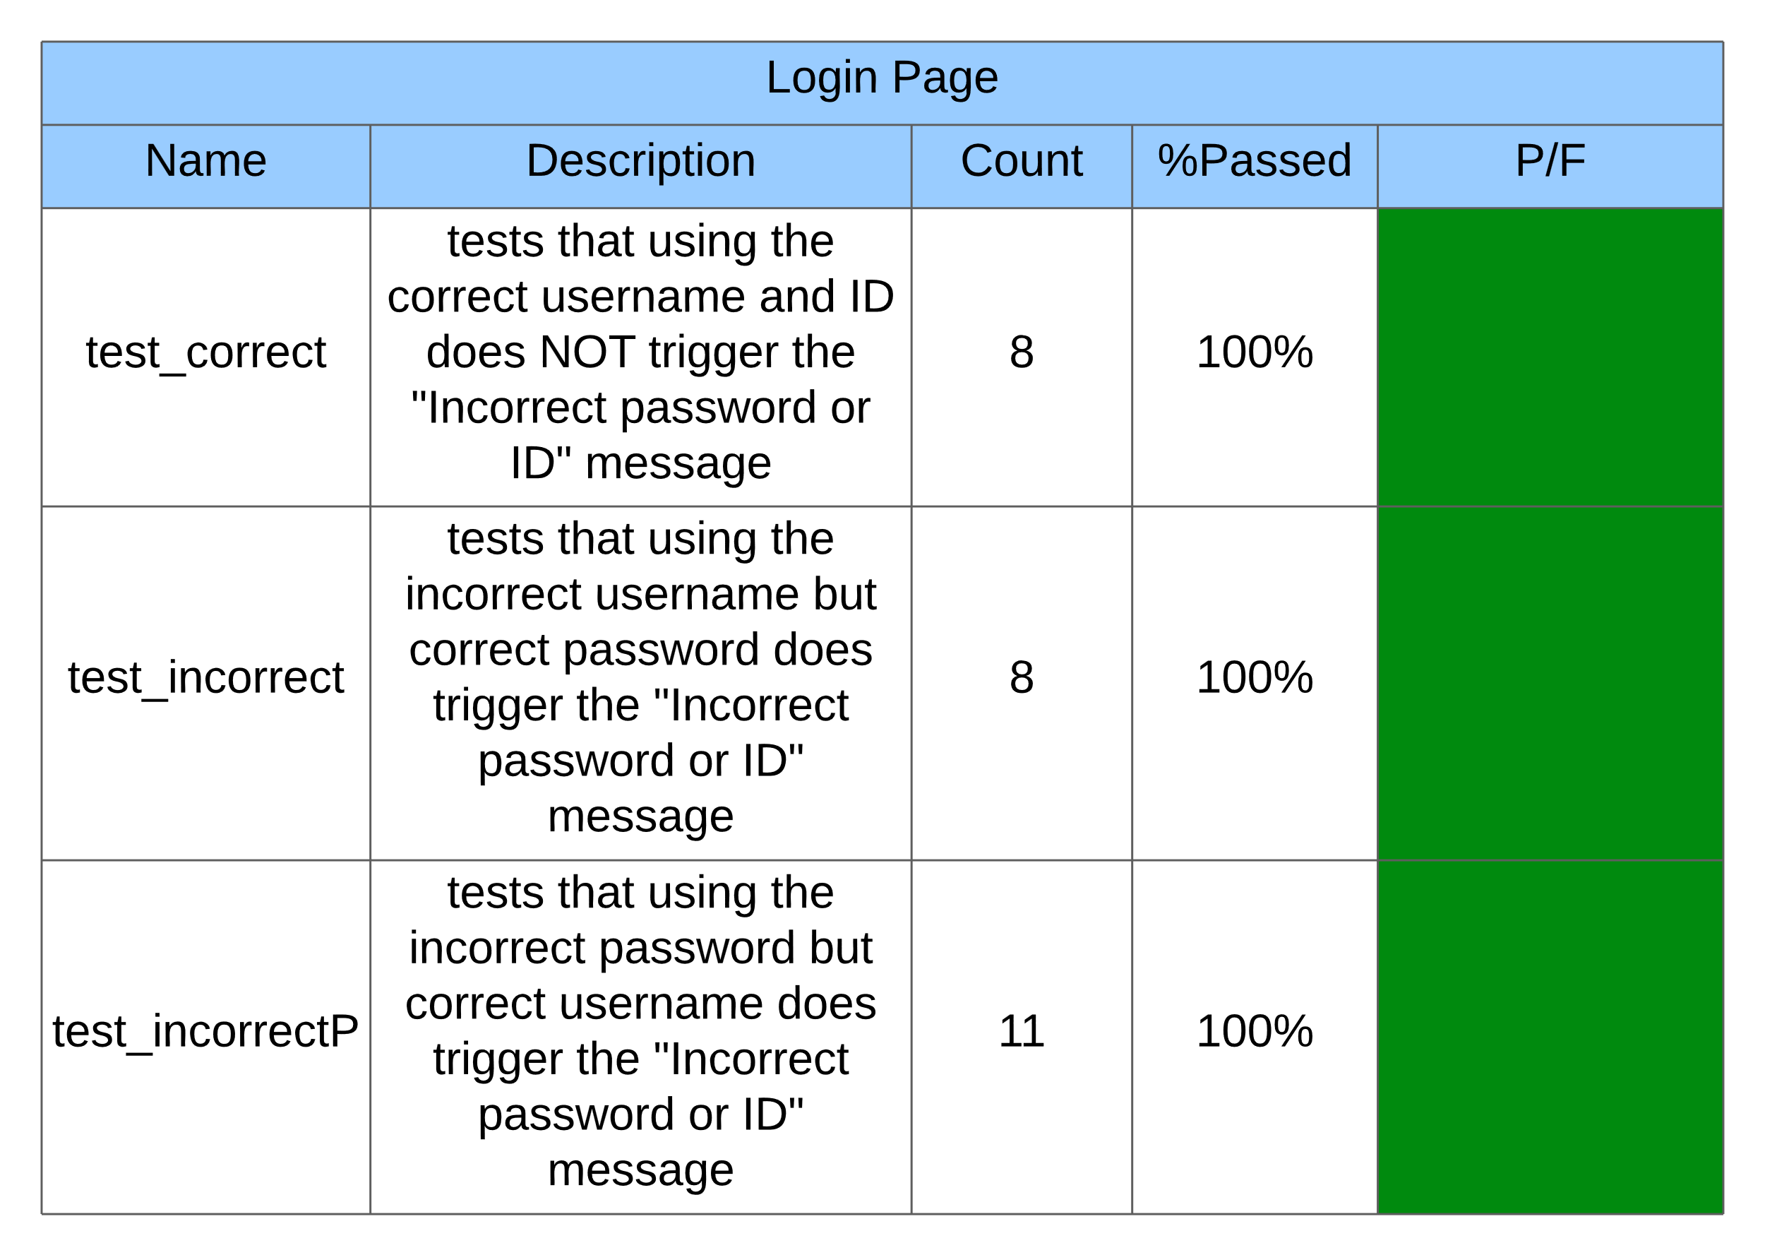

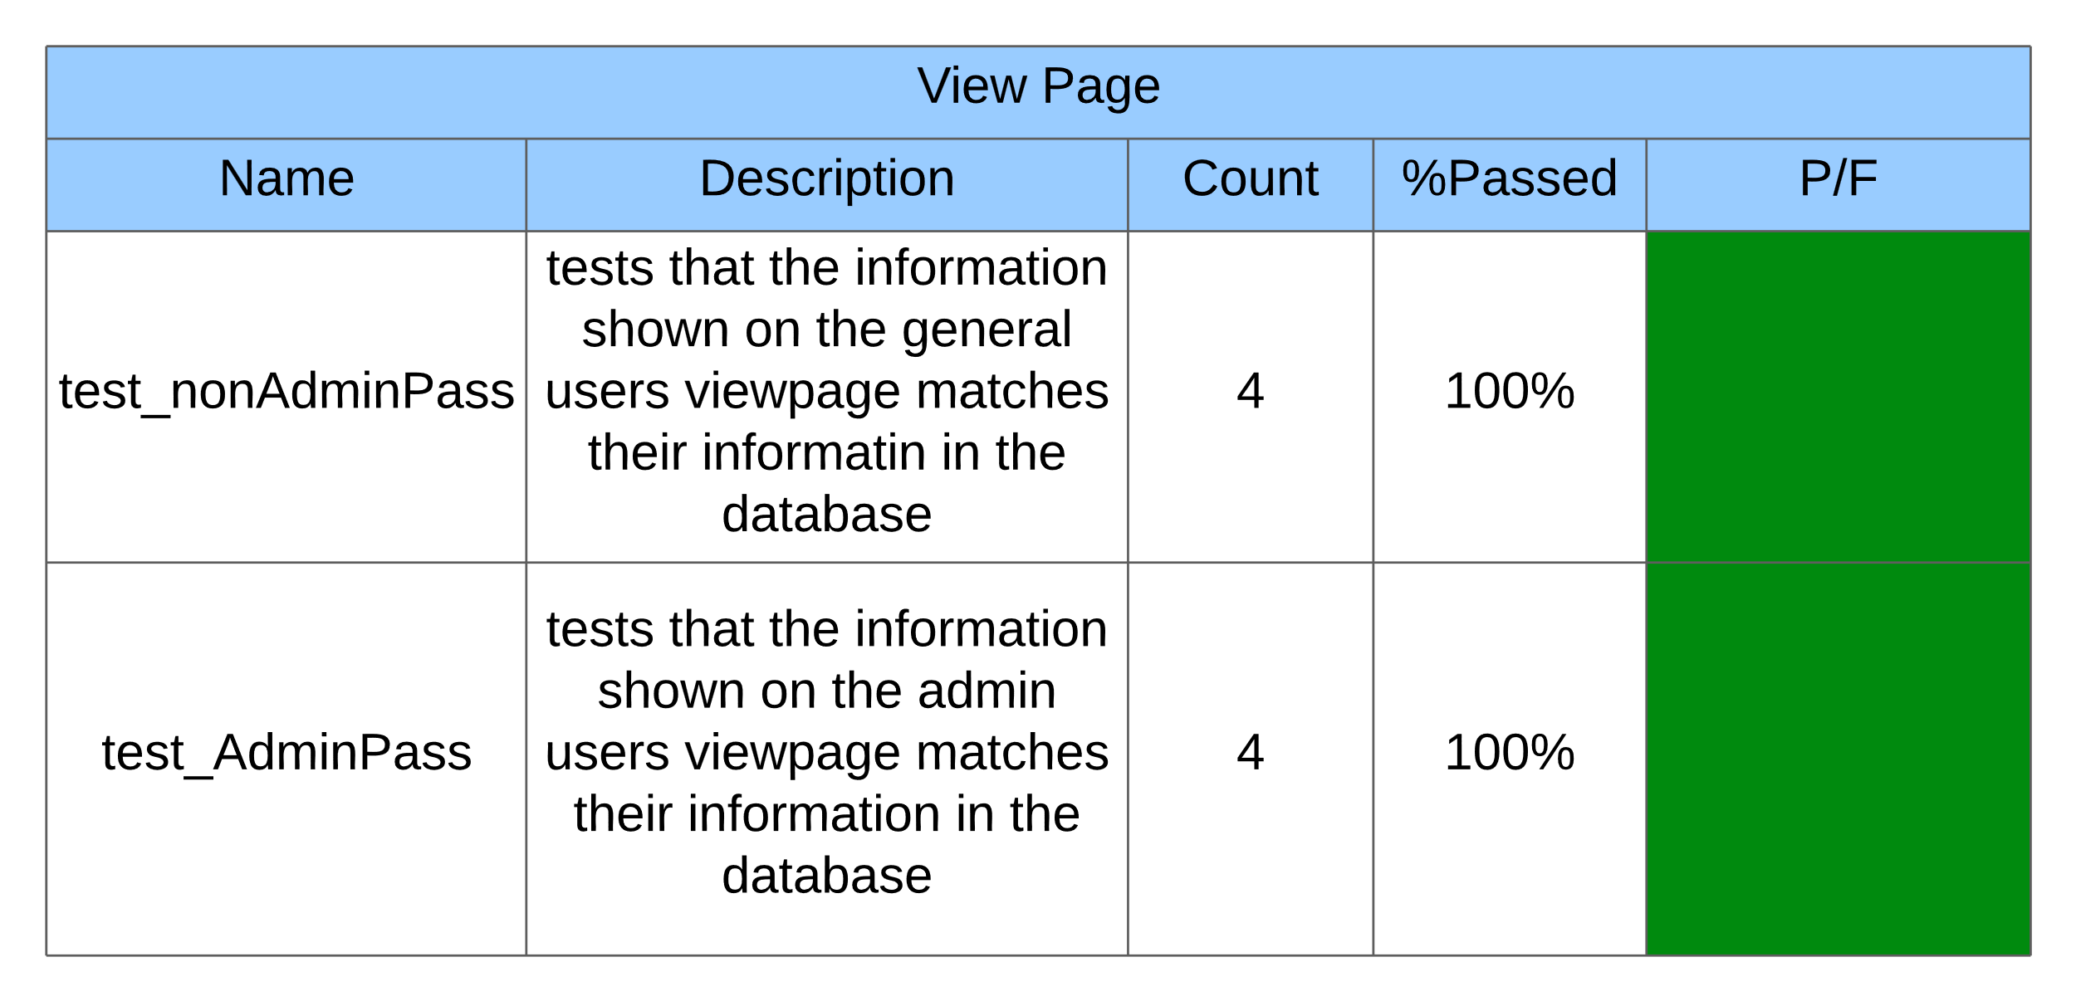

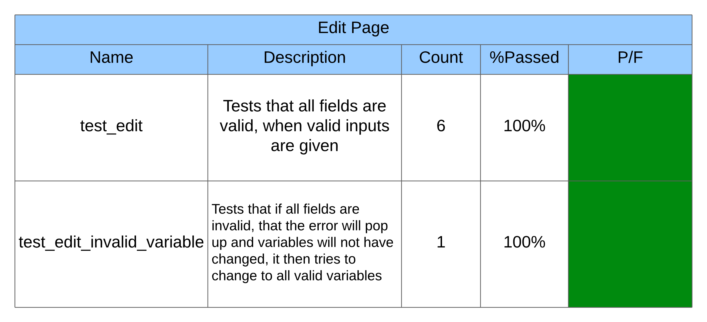

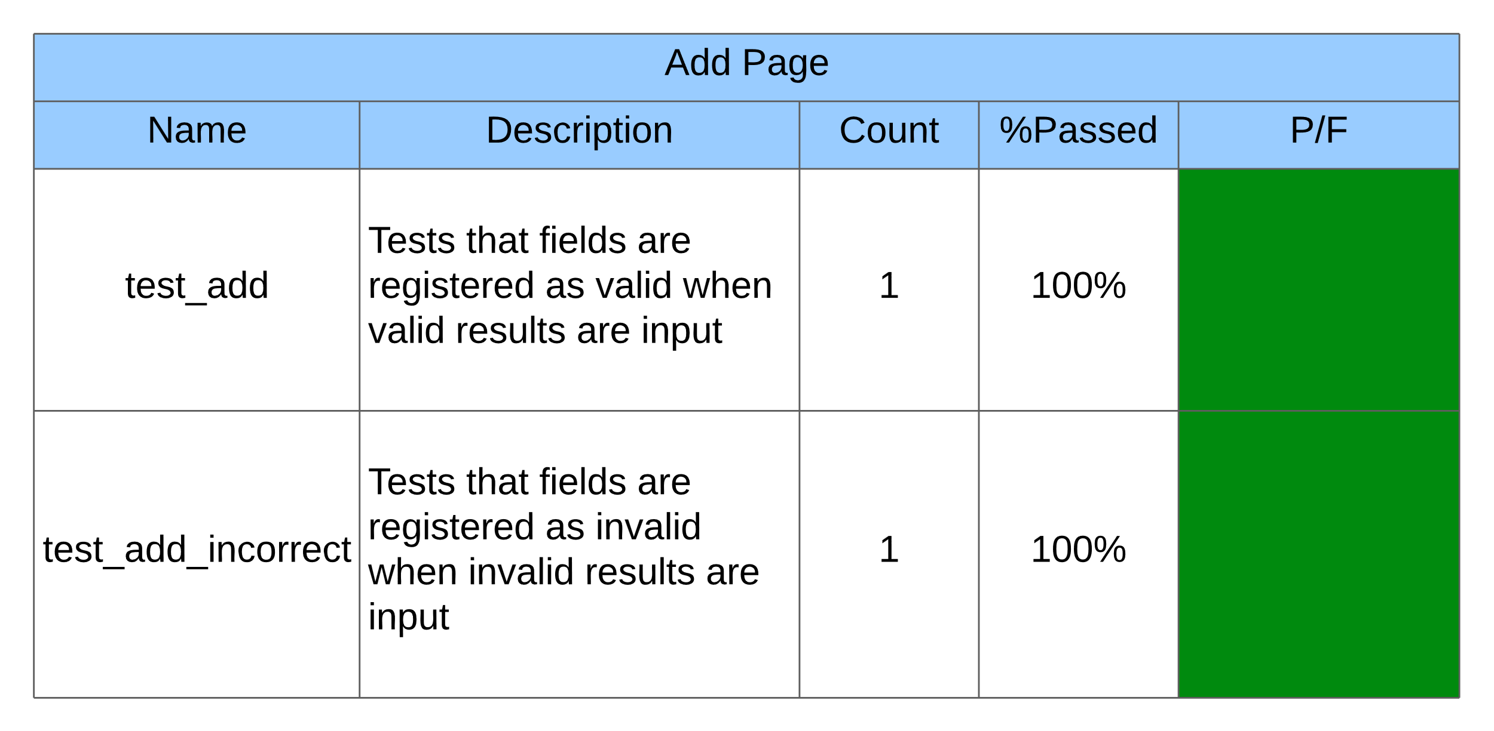

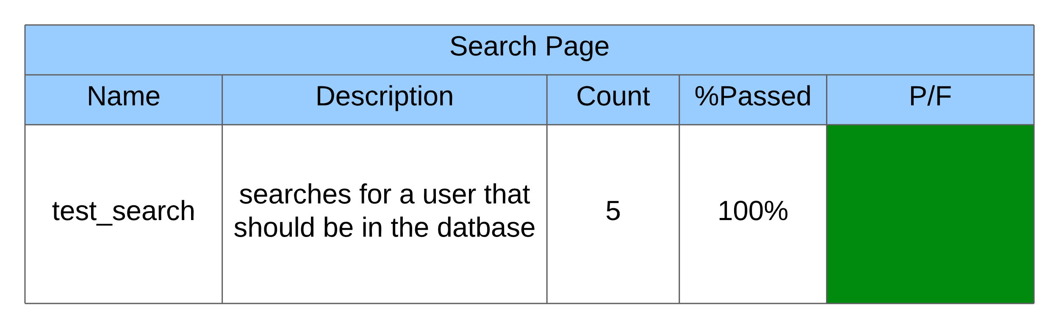

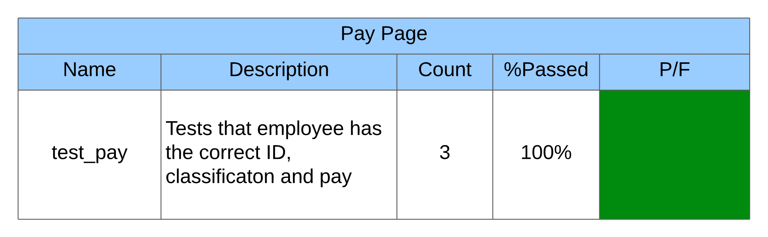

#### Usability Test

Summary: Cody Strange ran the usability test because he has the least amount of knowledge in dealing with the code.

* Test#1: I was unable to get the program running, I downloaded the zip file and tried to run every file that was there, at best they did nothing I could see. At worst they through errors. I was unable to get it running and will need to discuss this with the team to find out why it is not working.
* Test#2: I was able to get the program to work after adjusting one of the paths that are called in the code, I was brought to the login page and typed in the proper id and password and that worked fine. It instantly brought me to the Add Employee page, and only had a “Add Employee” button, “Cancel” button, and “Help” button. The help button through a message that said it was a work in progress. But when I tried to add an employee it would just say that I was missing fields even though I wasn’t. Once I hit the cancel button something very odd happened. Most of the fields disappeared and the ones that remained could not be edited. The page was still called “Add Employee”, the “cancel” button does not do anything. And I tried to exit out of the program but the “X” in the top right corner doesn’t work.
* Test#3: Cannot find out which fields that I am typing in are invalid, seems to require me to fill out an hourly wage, salary, and commission. Even though it asks me to decide which one to use. Also has me fill out the end date even though the employee is just starting.
* Test#4: Using the Thonny IDE we were able to get the program running properly, there were some fields that didn’t let the user know when they typed the incorrect information, but besides some minor inconveniences it was intuitive enough, besides that the payroll page should be properly explained in the user manual.

## Bug Tracking

#### Bug Tracking Plan

Summary: We are using backlog to keep track of bugs that appear in the program. When a new bug is discovered, the programmer/tester creates and ‘issue’ on backlog where they give the bug a brief name and detailed description of what the bug causes. It is then assigned to someone to fix and a due date to fix by and labels it so that it appears in the ‘Open’ section of the board. The assignee then moves it to the ‘In Progress’ section while he is fixing it. Once he fixes the bug it is then moved to the ‘Resolved’ section and the person who fixed it leaves a comment giving a brief description on how they fixed it.

#### Bug Report

Summary: The bug report has been slightly adjusted from last sprint, with the “Severity” category being renamed to “Priority.

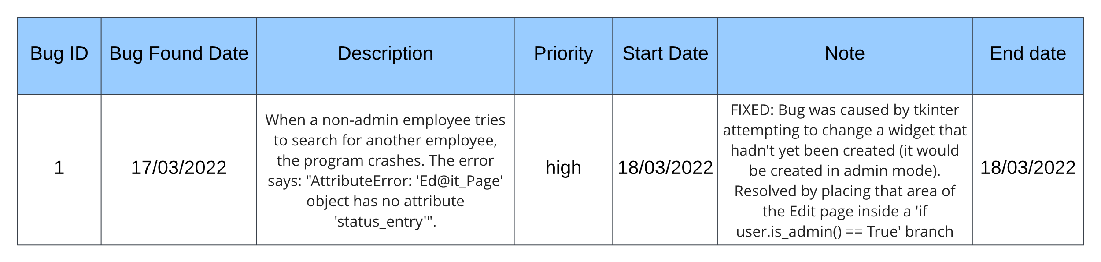

Charts/Forms

SPR-4 Work Breakdown Structure

*Chart*

Summary: This WBS chart shows the general responsibilities that everyone in the sprint were in charge of

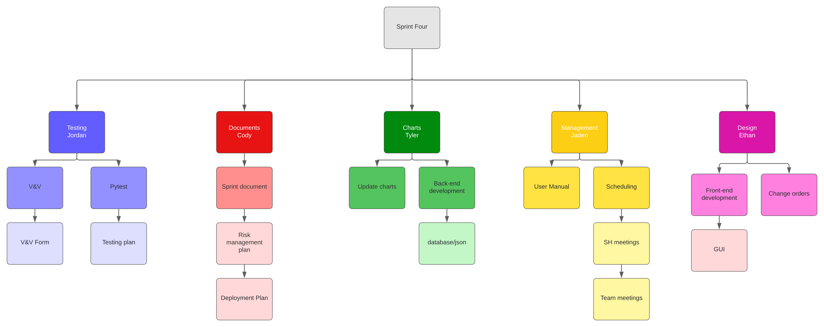

SPR-4 Pert Chart

*Chart*

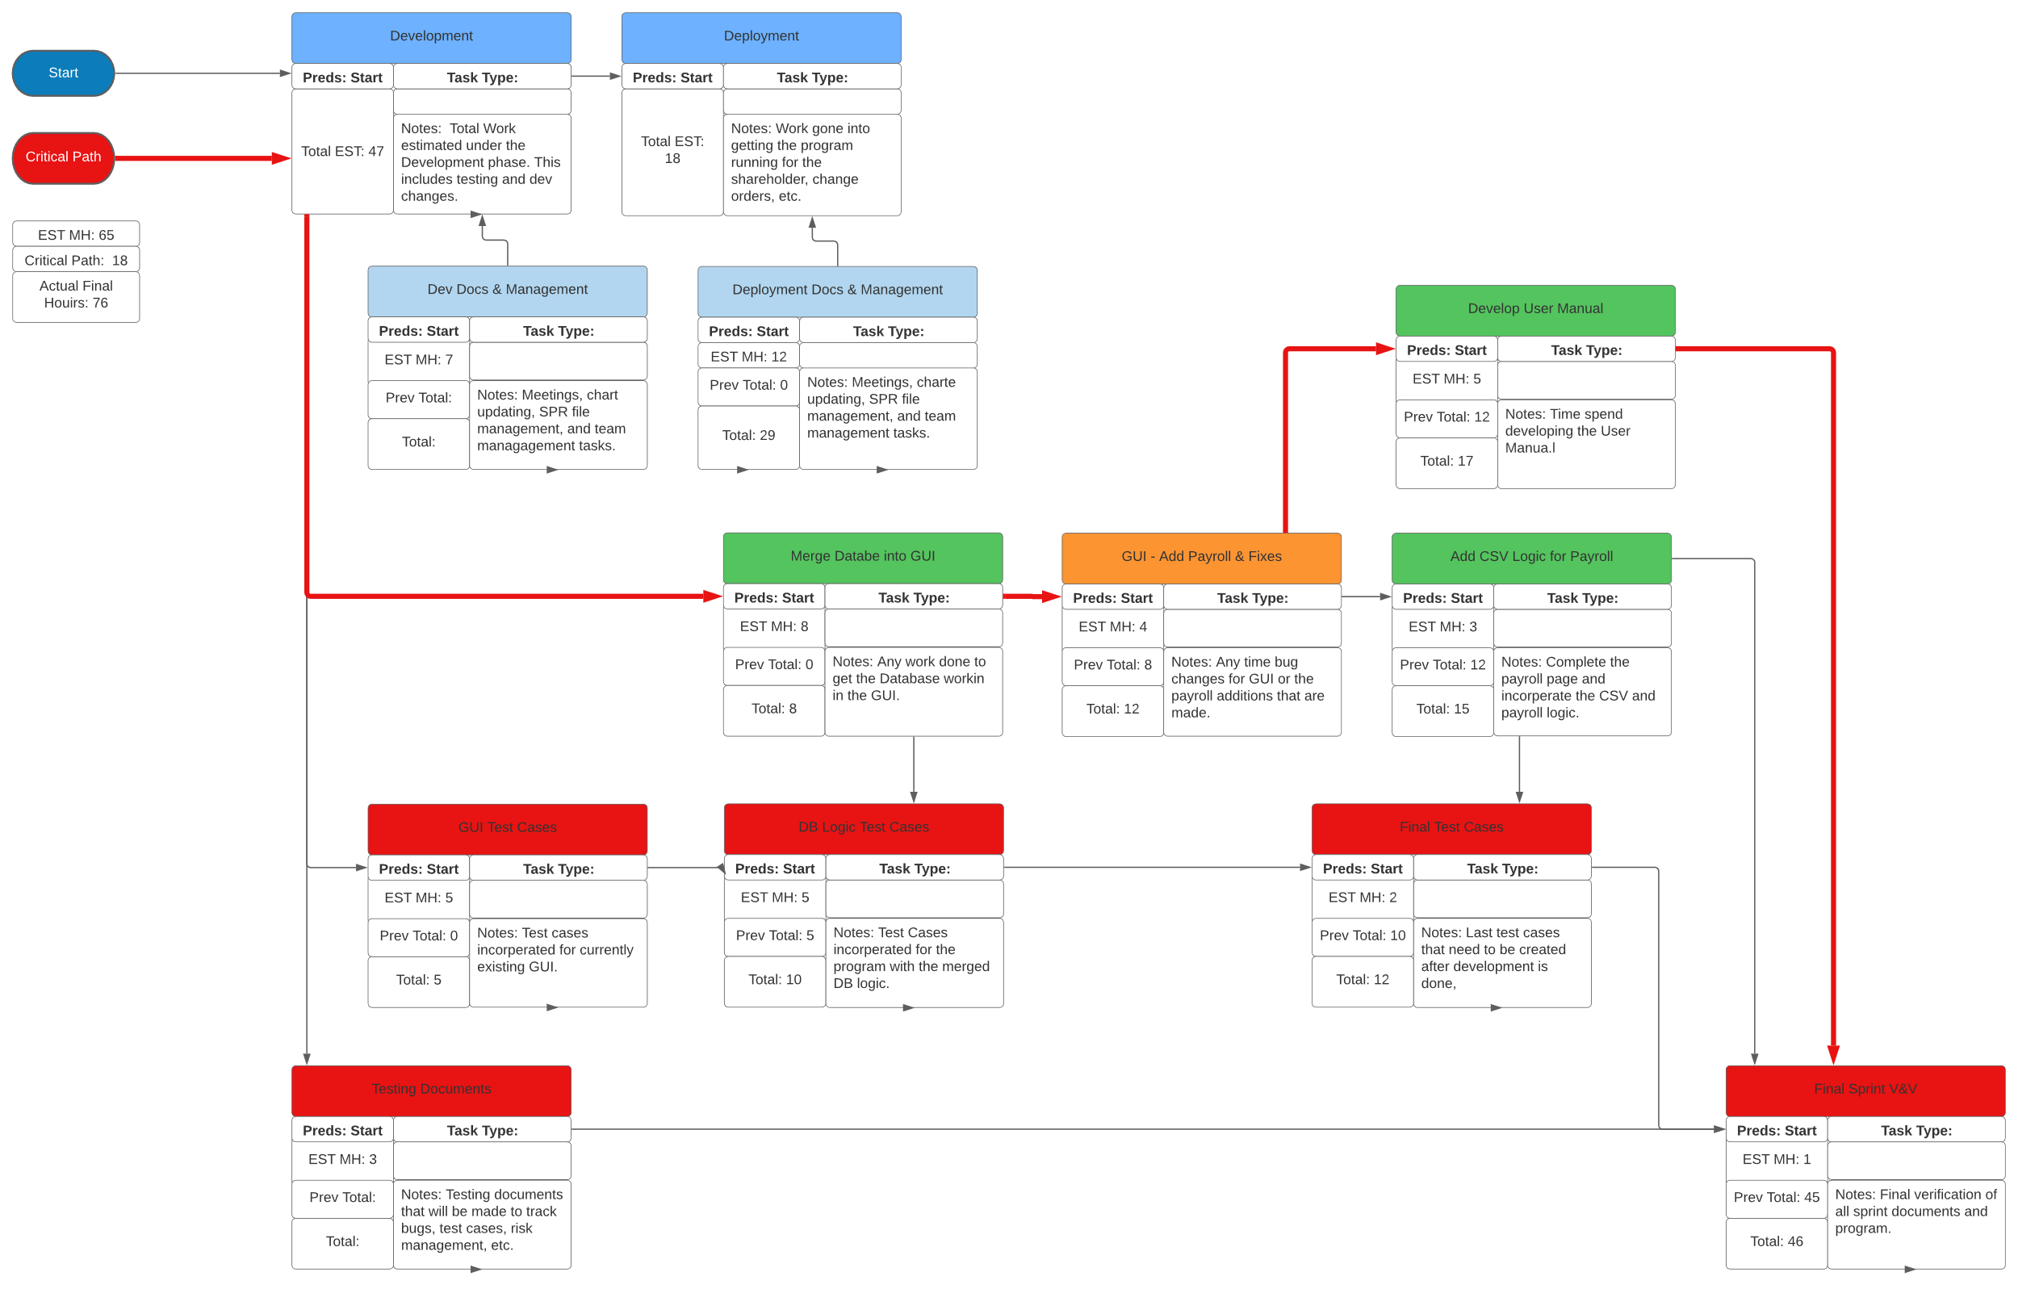

SPR-4 Gantt Chart

*Chart*

SPR-3 Burndown Chart

*Chart*

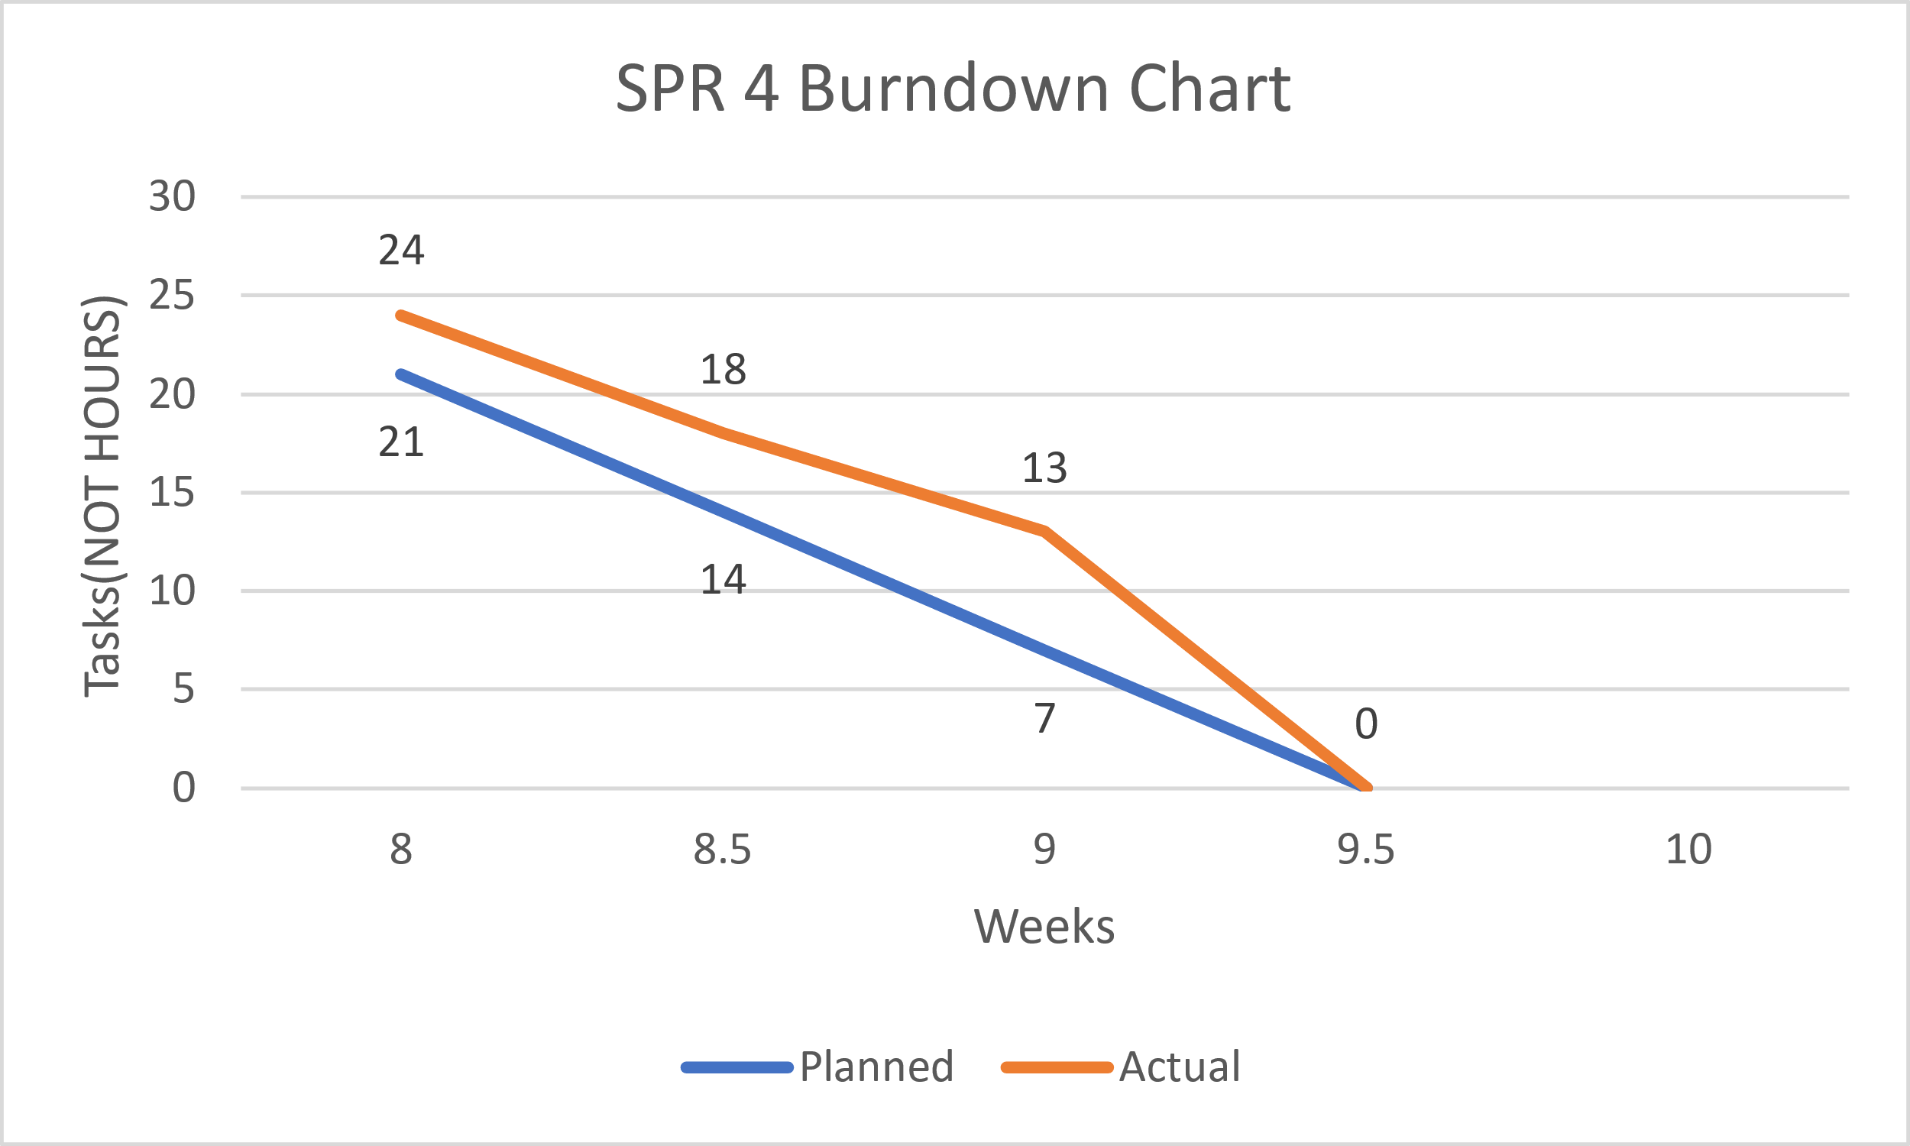

Meeting Logs

Meeting Log#14

Meeting Information

* Team #: T2-002
* Meeting log #: 14
* Current Sprint: SPR4
* Date: March 14, 2022
* Time: 7:00pm – 8:04pm (MT)
* Location: MS Teams (Watch video here)
* Attendees: Ethan Taylor, Jaden Albrecht, Cody Strange, Tyler Deschamps, Jordan Van Patten
* Next team meeting scheduled for: March 16, 2022, 3:50pm (MT)

Progress From Previous Meeting

* Ethan Taylor:
  + COMPLETED ALL TASKS FOR SPR3
* Jaden Albrecht:
  + Keep meeting logs up to date (100%)
  + Change order request form (100%)
* Cody Strange
  + SPR3 document (100%)
  + Testing documents (100%)
  + Change request board (100%)
  + Risk management plan (100%)
* Tyler Deschamps:
  + Update pert/Gantt/burn-down charts (100%)
* Jordan Van Patten:
  + Research PyTest
  + Research Black/Pytest
  + Read Chapter 7 (100%)
  + V&V documents (100%)
  + Test cases (75%))
  + QA plan (100%)

Topics Discussed

* Changes to final SPR3 document
* User manual
* Testing plans
* Maintenance plans
* Usability test cases
* Bug tracking method
* Assign role for new team member in SPR5
* Refining database functionality with GUI
* Next shareholder meeting

Obstacles Encountered

* No obstacles

Finished Items

* All charts are up to date
* Meeting logs are up to date
* SPR3 document
* Testing pseudocode
* Assigned new team member as a coder/tester

Unfinished Items

* Wired GUIs with database
* Usability test cases
* Tested all components using PyTest
* Testing documents
* V&V documents for SPR4
* Risk management plan for SPR4
* Maintenance plan
* WBS for SPR4
* User manual
* Schedule next shareholder meeting

Tasks Until Next Meeting

* V&V documents for SPR4
* Wire all GUIs to database
* Implement field validation code into GUI
* Risk management plan
* Testing documents
* Usability test cases
* Maintenance plan

Notes

* At the time of this meeting, we only had worked on tasks assigned from SPR3.

Meeting Log#15

Meeting Information

* Team #: T2-002
* Meeting log #: 15
* Current Sprint: SPR4
* Date: March 16, 2022
* Time: 3:50pm – 4:34pm (MT)
* Location: MS Teams (Watch video here)
* Attendees: Ethan Taylor, Jaden Albrecht, Cody Strange, Jordan Van Patten
* Next team meeting scheduled for: March 18, 2022, 7:00pm (MT)

Progress From Previous Meeting

* Ethan Taylor:
  + Implement add/edit validation code into GUI (100%)
  + Update payroll page (100%)
  + Tkinter research
* Jaden Albrecht:
  + Keep meeting logs up to date (100%)
  + Chapter 8 (100%)
* Cody Strange
  + WBS for SPR4 (100%)
  + Research requirements for SPR4 (100%)
* Tyler Deschamps:
  + Update pert/Gantt/burn-down charts (100%)
  + Report receipts (100%)
  + Implement GUI and database logic (100%)
  + Merge database with Emp_Dat_V3 (100%)
* Jordan Van Patten:
  + Implement validation code to GUI (100%)
  + Test cases for search page (100%)

Topics Discussed

* User manual
* Testing plans
* Maintenance plans
* Usability test cases
* Refining database functionality with GUI

Obstacles Encountered

* No obstacles

Finished Items

* All charts are up to date
* Meeting logs are up to date
* Implementation of add/edit validation code
* Updated payroll page to work with JSON database
* WBS for SPR4
* Merge database with Emp_Dat_V3
* GUI and database logic implementation

Report receipts

* Test cases for search page

Unfinished Items

* Test cases for payroll page
* Testing documents
* V&V documents for SPR4
* Risk management plan for SPR4
* Maintenance plan
* User manual
* Schedule next shareholder meeting

Tasks Until Next Meeting

* V&V documents for SPR4
* Risk management plan
* Testing documents
* Usability test cases
* Maintenance plan

Notes

* No additional notes

Meeting Log#16

Meeting Information

* Team #: T2-002
* Meeting log #: 16
* Current Sprint: SPR4
* Date: March 18, 2022
* Time: 7:00pm – 7:45pm (MT)
* Location: MS Teams (Watch video here)
* Attendees: Ethan Taylor, Jaden Albrecht, Cody Strange, Tyler Deschamps, Jordan Van Patten
* Next team meeting scheduled for: March 21, 2022, 7:00pm (MT)

Progress From Previous Meeting

* Ethan Taylor:
  + Integrate database with pay page updates (100%)
* Jaden Albrecht:
  + Keep meeting logs up to date (100%)
  + User manual (80%)
  + Scheduled next shareholder meeting (100%)
* Cody Strange
  + Usability tests (30%)
  + Risk management for SPR4 (100%)
  + Maintenance plans (100%)
  + Deployment plan (100%)
  + SPR4 document (70%)
* Tyler Deschamps:
  + Update pert/Gantt/burn-down charts (100%)
  + Merge database with Emp_Dat_V3 (100%)
  + Payroll and CSV integration (100%)
* Jordan Van Patten:
  + Make Pytest documents for payroll page (60%)

Topics Discussed

* User manual
* Testing plans
* Maintenance plans
* Usability test cases
* Next shareholder meeting

Obstacles Encountered

* No obstacles

Finished Items

* All charts are up to date
* Meeting logs are up to date
* Integrate database with pay page updates
* Risk management plan for SPR4
* Maintenance plans
* Deployment plan
* Test plans
* Merge database with Emp_Dat_V3
* Payroll and CSV integration

Unfinished Items

* Test cases for payroll page
* Testing documents
* V&V documents for SPR4
* User manual

Tasks Until Next Meeting

* V&V documents for SPR4
* Testing documents
* Usability test cases

Notes

* No additional notes